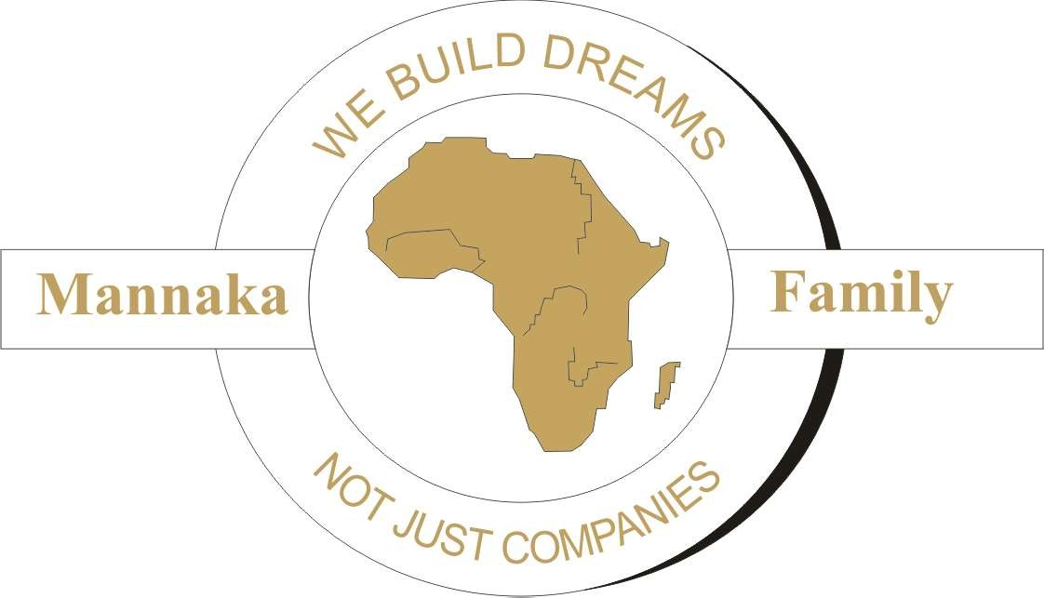

Company Profile

BUSINESS DEVELOPMENT:

BACKGROUND
Mannaka Family is a 100% black owned and controlled organization, which comprises of a consortium of a monopoly of experienced business that specializes in most fields in the industry. The Mannaka Family has the commitment, skill and resources to meet the requirements of their customers.

VISION
We see Micro Enterprises (M.E.s), Small/ Medium Enterprises (S.M.E.s) and Entrepreneurs growing into large corporate (PTY.LTDs) in the next 5 years through guidance, mentorship and knowledge of a 1 stop shop (The Mannaka Family).

MISSION
We are dedicated to total excellence and value-added service to take these MEs, SMEs and Entrepreneurs to become some of the greatest corporate in South Africa so they may fight unemployment and eradicate poverty until it is merely a word of a vivid imagination of the old régime of an apartheid era.

VALUES
In conducting our business we embrace a core set of values, which are our competitive advantages and are as follows;
HONESTY; INTEGRITY; RELIABILITY; PROFESSIONAL QUALITY SERVICES & CONFIDENTIALITY

OUR COMMITMENT
We distinguish ourselves from the competitors by delivering prompt and accurate service to our customers in the most professional, efficient and reliable manner.
We give our customers the assurance that we will be there when they need us.

AREAS OF SPECIALIZATION
Mannaka Family specializes in all areas within all industries. We like to focus on initial set up of businesses and run with clients, to give a more hands-on approach.

OUR CORE SERVICES
- Business Development * Trade marking
- CCMA & Labour Relations * Copyright
- Job Description & Evaluation * Patenting
- Company Structure & Policy * Vat, Company Tax & Accounting
- Business Plans * Construction, painting & refurbishing
- Computer Skills * Television Production
- Business Registrations * Mentorship
- Events & Functions * Accommodation, Tours & Shuttling

SOCIAL DEVELOPMENT
Mannaka Family fully subscribes to the development of previously disadvantaged individuals, in terms of race, gender and disabilities. This policy is to directly and indirectly develop skills by;
- Empowering previously disadvantaged individuals.
- Associating and supporting suppliers and companies which apply black empowerment policies.
- Supporting, guiding and developing our Entrepreneurs to fulfill their dreams and ambitions.
- Becoming the greatest economy in the world by using our abundant supply of natural resources in Africa.

Mannaka Family has thus far only employed un-educated, un-skilled workers. The majority of these are from a disadvantaged background which in turn is creating skill development, fighting unemployment and creating sustainable development in Africa. We have a business development specialist (Mr. Marvin Domingo)* on site to train and skill them, at low costs to the company

OTHER SERVICES
- Vat, Tax and Accounting Training-do your own books
- Corporate administration
- Video Production Training
- Design, Publications and Advertising
- Project Management
- Construction, Refurbishing & Painting Training
- Arrange for free government marketing, business development and training finance

WHO WE ARE AND WHAT WE DO
Mannaka Events, Projects and productions:
We head all my companies’ projects personally.
Road to Xnau flighted on ETV 29 January 2006. Women in Religion on SABC in May 2006.
Sitengi, Cacadu, Free film- training young producers for Eastern Cape Government
Set up Mannaka’s Cultural guest House in Port Elizabeth
Set up Mannaka’s Guest House behind OR Tambo Int. (Incl. construction) Coega CDC Building with LTA Grinaker.

Tourism/ accommodation training and mentorship. Currently we are planning setup of Mannaka Guest House Jeffreys Bay (34 en-suite bedrooms).
We are planning to add 12 more rooms to Mannaka’s Guest House in Nelson Mandela Bay (Port Elizabeth).
More on www.mannakafamily.com and www.mannakaguesthouse.com

My Expertise: Intellectual Property; Trade Marking; Copy Right; Business Registration; Patenting; CCMA and Labour Court; Job Description and Evaluation; Company Structure and Policy; Vat, Accounting and Business Plans; Construction; Computer Skills(word, exel,autoCAD, PowerPoint, Access); Branding, Web Design, Letter heads, Business Cards, Marketing, Sales, etc…

Setting up your business from initial setup through the developmental stage until it formulates into a successful enterprise.

EVENTS, FUNCTIONS, PROJECTS AND PRODUCTIONS

MANNAKA PRODUCTIONS AND EVENTS Division, founded in 2005 to serve clients who value industry experience, strategic thinking and proven solutions. We are 100% black owned multi-faceted company with a vast network of relationships. This allows us to identify the right needs for your particular communications/event management projects, media, publicity, marketing and audio & visual productions. Our plans integrate the right mix of services to achieve your bottom line. Our first step with
every client is to develop a comprehensive strategy; this process provides a roadmap for each client’s needs.

We provide expertise in the design and execution of high-quality audio & visual productions, media, marketing, communications, and event management services
Then we deliver... on time and on budget accurately with limited contingency.
If your company would like to receive the immediate and long-term benefits contact us at: MarvinDomingo@mannakafamily.com
www.mannakafamily.com

We Offer:
Press and Publicity Services
- Few businesses can afford to avoid the media . . . .

. . . . because most need good publicity in order to thrive. Advertising is all very well, but when a journalist mentions your company, readers and listeners are much more likely to sit up and take notice. To make the most of the media, you need someone who knows how it operates and how to use it effectively. Or if you are launching a new product or service you could well benefit from the copywriting skills of an experienced journalist who knows how to “turn the press on” or give a professional edge to customer newsletters, brochures or in-house publications.

MANNAKA PRODUCTIONS & EVENTS Division can provide a complete press and publicity service for businesses and individuals including: -
  - Writing and distributing press releases
  - Production of press packs and briefing notes
  - Copywriting (for brochures, websites, corporate video’s, newsletters, trade journals, etc)
  - Damage limitation advice
  - Campaign organization (including sponsorship)
  - Arranging press conferences and photo calls
  - Media handling advice
  - Lodging press complaints
  - Fee negotiation for media interviews, where appropriate
Supply of outside facilities such as photography, graphic design, speech writing services, media monitoring, video production, etc.
MANNAKA PRODUCTIONS & EVENTS Division also offers a ‘How to do your own PR’ seminar. This covers what PR is; what it can and can’t achieve; what ‘the media’ is and what it wants; recognizing, creating and ‘selling’ a good story; writing and distributing press releases; handling press conferences and photo calls; sponsorship; campaigns; responding to hostile media enquiries; damage limitation and making media complaints.

Events Hosting & Management :-
- Sometimes, PR and advertising simply aren’t enough sometimes
you need to provide a metaphorical ‘shop window’ for your products or services – an exhibition, conference or promotional product launch. At other times, you need to focus on your internal communications and plan a team building weekend, party or AGM.

MANNAKA PRODUCTIONS & EVENTS Division can organize: -
  - Venue searches
  - Speakers and celebrity guests
  - Organization and administration before, during and after the event
  - Sponsorship
  - Advertising and marketing
  - PR and media handling
  - Event websites, brochures and other publicity material
  - Audio-visual equipment
  - Catering
  - Exhibition and conference staging
  - Entertainment
  - Promotional items (balloons, car stickers, banners, etc.)
  - Accommodation advice
  - Insurance

Customer Relations Management
- Your staff are the first people your customers meet . . .
. . . and how they behave determines whether your business succeeds or fails.
The product or service a customer wants can be available from your business at the right price, but if your staffs are rude, unhelpful or vague, customers may still walk away without buying and never come back. Worse still, research shows they will tell at least seven other people not to bother dealing with your company either.

MANNAKA PRODUCTIONS & EVENTS Division offers practical workshops covering: -
  - How to welcome customers and put them at their ease, in person and on the telephone
  - The “Three A’s” of success – attitude, appearance and ability
  - Selling pitfalls to avoid
  - Taking orders
  - Clinching a sale
  - The most common customer complaints and how to avoid them
  - Turning complaints into success stories
  - Getting repeat business

Voice and Presentation Training
- After our face, people next notice our voice . . . . .

. . . . and from our voice, they make assumptions about our background, education, abilities and even our income. If you need to attract the attention of others in conversation, on the telephone, for speeches, presentations, or on radio or television, it is imperative you know how to make the most of your voice. Voice and Presentation

Training includes: -
  - How to use and control your voice effectively
  - Breathing, posture and relaxation techniques
  - Creating successful speeches and presentations
  - Using visual aids
  - Handling Questions
  - Getting back on track if something goes wrong
  - Speaking in different environments (Radio, television, presentations, lectures, telephone, etc)
  - Media interview training, including studio sessions with journalists in
either a radio or TV environment, is also available by special arrangement. about us

MANNAKA PRODUCTIONS & EVENTS Division’s diverse team consist of People who worked for more than ten years in electronic and print media, entertainment, event hosting, management and productions . . .
Our working knowledge of media/ entertainment, event hosting and management. has placed this team in an excellent position to assist businesses, charities and ndividuals, improve their public image, reputation, performance and short and long-term goals.
MANNAKA PRODUCTIONS & EVENTS Division, work with a network of current and former media professionals to provide press and publicity services and voice, presentation and media interview training.

The Team members with publicity and marketing experience realized the importance of backing up effective PR and publicity by good customer service and went on to develop a customer relations management unit.
MANNAKA PRODUCTIONS & EVENTS Division also directs itself towards managing whole business images. In a rapidly expanding media age, the companies that succeed:
- are those, which create effective publicity,
- keep their client base happy,
- When things do go wrong, offer quick reparation and believable damage limitation.
- Have lucid, entertaining and authoritative spokespeople who get their message across without alienating their audience.
- Whose events clients, journalists, clients and staff alike want to attend again and again.

Audio Visual Production Services
- Few businesses can afford to tarnish their image by enquiring sub-standard audio visual profiles, corporate visuals and television productions . . . .

. . . . because most of us need a good corporate image in order to thrive. The new medium of boosting your corporate structure is by having and audio visual profile. They say that a picture says a thousand words. Imagine what a motion picture can do. To make the most of the media houses/ web facilities/ capital audiences, you need someone who knows what is required to achieve the maximum exposure needed in the business world. Or if you are launching a new product or service you could well benefit from the copywriting skills of an experienced production facilitator who knows how to Write, Direct and Produce the visual product that is most needed by your company.

MANNAKA PRODUCTIONS & EVENTS Division can provide a complete audio visual production service for businesses and individuals including: -
  - Corporate audio visual profiles
  - Script Writing
  - Copywriting/trademarking of your product
  - Assisting and preparing you for pitching a documentary, series or film at the broadcasting unit (e.g. SABC, ETV, MNET)
  - Acquiring all documentation for broadcaster (e.g. tax clearance certificate, company registration, vat/tax reg.)
  - Directing and producing your product
  - Media Media publication of product
  - Budget
  - Editing

We have an outstanding reputation in this field with: ETV (Road to Xnau), SABC (Women in Religion), Nelson Mandela Bay (Freefilm-training young producers in film and media), etc...

CONTACT US
Page 12
MANNAKA FAMILY

28 FOREL STREET 72 KOBUS ROAD 71 Aubrey Street BONAERO PARK GELVAN DALE Gelvanpark
KEMPTON PARK Nelson Mandela Bay Nelson Mandela Bay
TEL: (011) 395-3861 TEL: (041) 452-4450
FAX: 0866 569 307 FAX: 0866 569 307

POSTAL ADDRESS P O BOX 2318 KEMPTON PARK 1620

E-MAIL : marvindomingo@mannakafamily.com WEBSITE : www.mannakafamily.com

