PROPOSED MEETING AGENDA
140 Worcester Street, West Boylston, Massachusetts 01583 In accordance with the provisions of MGL 30A §§ 18-25

CONSERVATION COMMISSION |  | NOVEMBER 2, 2017
Board / Committee Name |  | Date of Notice
WEST BOYLSTON TOWN OFFICES |  | LAND USE MEETING ROOM, #120/131
Meeting Place |  | Conference Room Number or Location
MONDAY, NOVEMBER 6, 2017/7:00 PM |  | TOBY S. GOLDSTEIN, CLERK
Date / Time of Meeting |  | Clerk or Board Member Signature

Meeting CANCELLED or POSTPONED to: |  | Date of Cancellation or Postponement

Notices and Agendas are to be posted 48 hours in advance of the meetings, excluding Saturdays, Sundays and legal holidays. Please note the hours of operation at the Town Clerk’s Office to ensure that this posting will satisfy this requirement.

This is the current list of topics that the Chair reasonably anticipates will be discussed at this meeting.

AGENDA
7:00 CONTINUED PUBLIC HEARING, JAMES ZINGARELLI, NOTICE OF INTENT, 9 MALDEN STREET, DEP FILE #327-
0273

7:15 PUBLIC HEARING, MICHAEL COVENEY, WEST BOYLSTON WATER DISTRICT, NOTICE OF INTENT, OFF TEMPLE STREET (MAP 160, PARCEL 16)(PLEASANT VALLEY WELL SITE)-ALSO VOTE BY BOARD ON CHARGING OF FEES

7:30 CONTINUED PUBLIC HEARING, ANDY BEARDSLEY, REQUEST FOR DETERMINATION OF APPLICABILITY, 19 CRESCENT STREET

7:45 CONTINUED PUBLIC HEARING, STEVE COOLEY, BETHLEHEM BIBLE CHURCH, NOTICE OF INTENT, 307 LANCASTER STREET – THIS PUBLIC HEARING HAS BEEN CONTINUED TO THE JANUARY 8, 2018 MEETING AT THE REQUEST OF THE APPLICANT

OTHER BUSINESS:
Approval of Minutes from prior meeting-OCTOBER 2, 2017 – addition of David Mercurio’s letter
Discussion of Tentative 2018 Concomm Meeting Schedule
Board Discussion of Possible Letter of Appreciation to Gerardo, Town Administrator and Economic Development Discussion of October Town Meeting
Update on Project Roundtable, Andy Beardsley, 19 Crescent Street
Treasurer’s Report and/or financial approvals
Next scheduled meeting – DECEMBER 4, 2017
Motion to adjourn

Save this file as Year-Month-Day-Name of Committee-Agenda [Example: 2017-10-15-ZBA Agenda.docx] Convert the Word file to PDF (File, Export, Create PDF/XPF Document) and forward to the town Clerk’s Office.

Town Clerk: TownClerk@WestBoylston-MA.gov

COMMENTS REGARDING COMPOSITION AND USE

ASSUMPTIONS
- The Meeting Agenda Template should be uniform from Board-to-Board or Committee-to- Committee
- The template should be reasonably straightforward in appearance so that readers can become accustomed to finding topical data (Committee Name; date of event; Agenda Topics) in the same place for each viewing and/or each Committee/Board
- The template should be easy to use, especially for persons not familiar with the Word conventions or by one who is not a skilled typist
- Filled in templates should be able to “translate” well to .pdf format for Web Posting
- The Town Logo will appear only on the first page, no matter how large this document becomes.

SOURCE DOCUMENTS
- Parks Commission Agenda, March 2, 2017
- Facilities Implementation & Strategic Planning Committee Agenda, April 12, 2017
- 2017 Appointed and Elected Officials Handbook

ATTRIBUTES AND OPERATIONS
- This is a WORD document presented as a standardized template in table format, but with the “grid” of the table not visible except as a guide. Normal WORD typing conventions will apply. See Illustration 1, below.

- Format: Calibri 10 Font (non-serif)
  - Single spacing 1.0

  - Spaces before and after paragraphs have been deleted

- In the Heading section, the user fills in ABOVE the shaded title cell

- In the AGENDA section, the user simply types as in a normal Word document. The typing will wrap as required.

- All cells are indented from the left margin

- To add additional rows for data entry, place the cursor in any location within the body (lower portion) of the template. From the formatting ribbon at the top of the page, select the “Home” Tab followed by “Layout” and then choose “Insert Above” or “Insert Below” the appropriate number of additional rows desired. See Illustration 2, below.

- To delete extra rows, first highlight all the “extra rows” (hold shift and scroll down to include all the extra rows you wish to be rid of) and then follow the instructions in 6), except choose Delete
– Delete Rows.

When the template is opened, this is what it looks like, with the lightly-shaded dotted lines. These are only for guidance for the typist, and will disappear when the final version is printed.

PROPOSED MEETING AGENDA
140 Worcester Street, West Boylston, Massachusetts 01583 In accordance with the provisions of MGL 30A §§ 18-25

Board / Committee Name |  | Date of Notice
Meeting Place |  | Conference Room Number or Location
Date / Time of Meeting |  | Clerk or Board Member Signature

Meeting CANCELLED or POSTPONED to: |  | Date of Cancellation or Postponement

Notices and Agendas are to be posted 48 hours in advance of the meetings, excluding Saturdays, Sundays and legal holidays. Please note the hours of operation at the Town Clerk’s Office to ensure that this posting will satisfy this requirement.

This is the current list of topics that the Chair reasonably anticipates will be discussed at this meeting.

Est.  Start Time | AGENDA
 | TOPIC
 | Approval of Minutes from prior meeting
 | Treasurer’s Report and/or financial approvals

Illustration 1

How to modify the Table (add or delete rows)

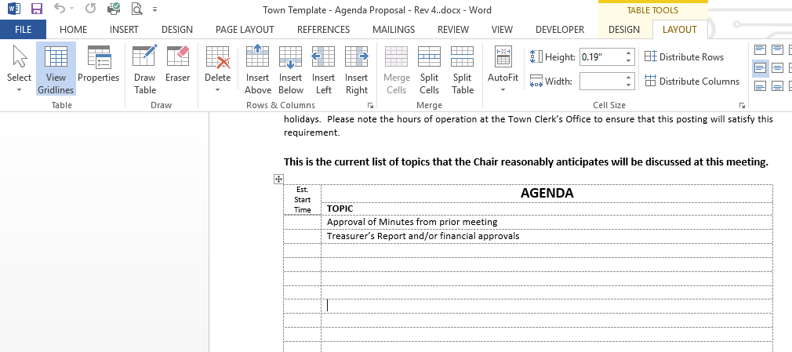
Illustration 2

