Purchase Order Invoice Checklist
Please follow these steps prior to submitting a Purchase Order invoice to Accounts Payable for payment.
Direct any invoice processing questions to AP-Processing@net.ou.edu.
Purchase Order Number
Once you receive the invoice, identify the Purchase Order to which the invoice belongs and write the PO number on the invoice.
Vendor Name
Ensure that the vendor name on the invoice matches the vendor name on the PO.
Received
Ensure that the goods/serviced billed on the invoice have been received.
Item Description
Ensure that the goods/services billed on the invoice are reflective of the item description on the PO. To view the details of the Purchase Order, navigate to Main Menu-Purchasing-Purchase Orders-Review PO Information-Purchase Orders and type in your PO number in the PO ID field. The Lines section of the Purchase Order Inquiry page will provide an item description for all lines on the PO.
PO Status and Purchasing Buyer
The Purchase Order Inquiry page will also show the PO Status and the Purchasing Buyer assigned to your PO. The PO Status should say Dispatched, meaning sent to the vendor. If it is in any other status, please contact the Purchasing Buyer assigned to your PO.
Funds
Ensure that there are enough funds on the PO to pay the invoice. To review the available funds, navigate to Menu-Purchasing-Purchase Orders-Review PO Information-Activity Summary and type in the PO number. Click on the Invoice tab and check that there are enough funds under the Un-invoiced Amount column.
Invoice or Distribution Lines
If your Purchase Order has multiple invoice lines or distribution lines, identify those on the invoice.
The invoice lines can be seen on the Purchase Order Inquiry page and to review the distribution lines, click on the Schedule icon and then click on the Distributions/Chartfield icon.
Amount to Pay
Identify the current amount to be paid. If that is the amount billed, highlight the amount. If that is less than the amount billed due to removal of taxes, late fees, etc., write in the amount to be paid and a reason as to why the payment is being reduced.
Highlight Information
Highlight on the invoice the PO number, invoice number, invoice date, remittance address and amount to be paid.
Signature
Have the invoice signed by an individual with budgetary approval.
Supporting Documentation
If there is any supporting documentation to add to the invoice, such as an Independent Contractor form or associated Credit Memos, paperclip those documents to the invoice. Please do not staple documents together.
Copies
Make copies of all documentation and retain for departmental records.
Submit to AP
Submit the original documentation to Accounts Payable for payment.

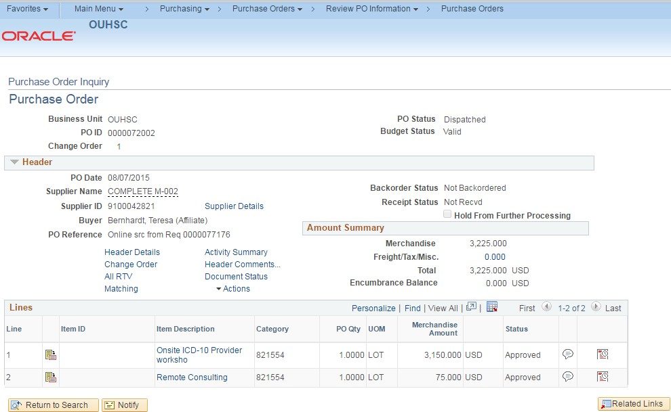PeopleSoft Information
Navigation
PO Status
Purchasing
Buyer
PO
Lines
Schedule
Icon

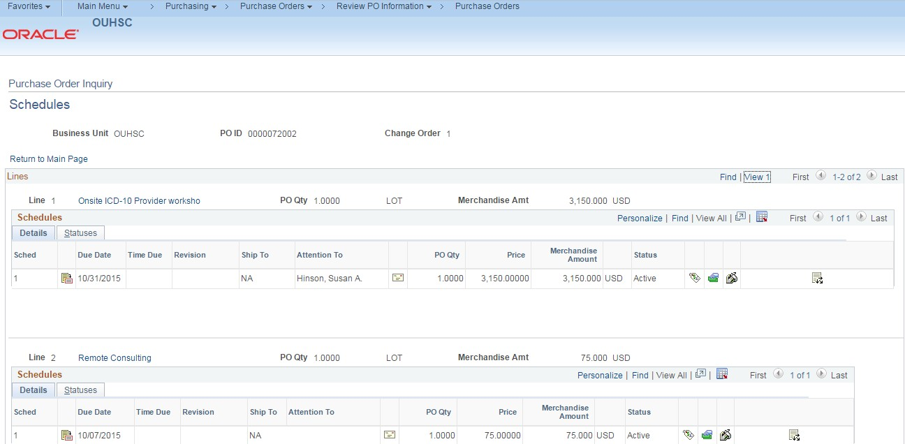

Distribution/ Chartfield Icon

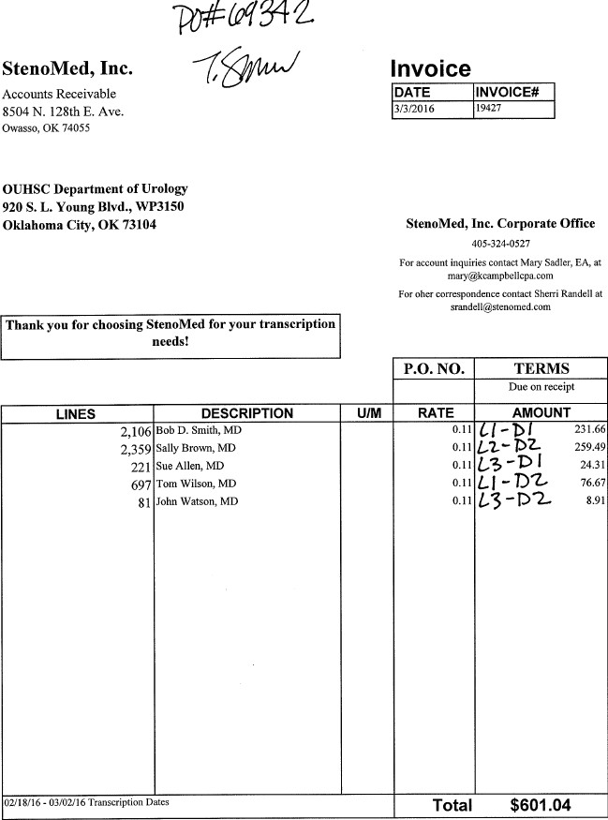Purchase Order Invoice Example

