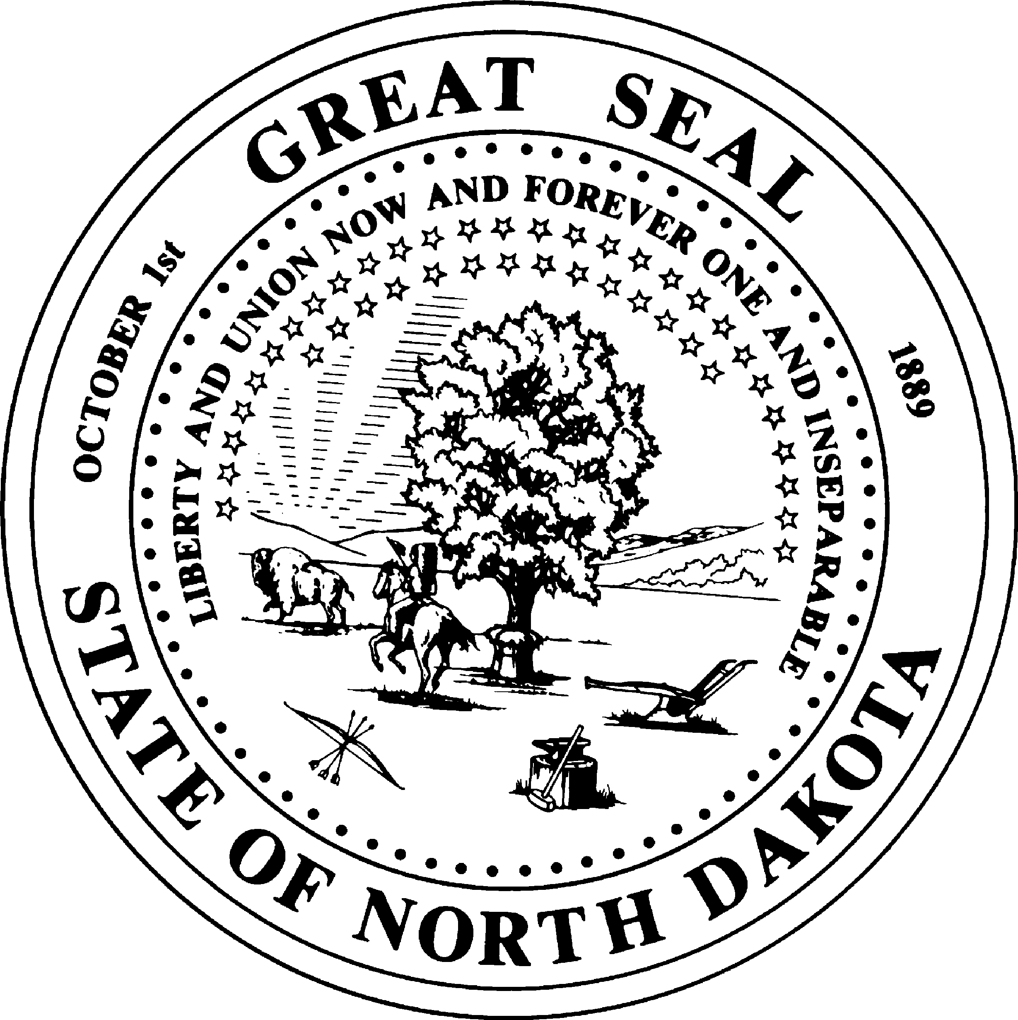
REQUEST FOR A PURCHASE ORDER
OFFICE OF MANAGEMENT AND BUDGET
CENTRAL SERVICES DIVISION - VENDOR REGISTRY
SFN 59970 (9-2012)

Please follow the Instructions on Page 2

Business Unit Number | Date Purchase Order is Needed | Agency Division, if applicable
Name of Employee Who Will Approve the Purchase Order |  | PeopleSoft User ID | Approver's Email Address
Agency Contact Who Will Work with Vendor |  | Vendor Name *
Address for Purchase Order |  | City |  | State | ZIP Code
* If this vendor is new to the PeopleSoft database, an IRS Form W-9 will need to be collected by the requesting agency before the vendor can be set up.
Types of Items Purchasing
Goods Services

Item 1 Description |  | Quantity | Price Per Item
For Goods: Item Should Be Shipped To | For Services: Division Location Where Service is Being Provided
Special Instructions or Details of the Item/Service Requested
Accounting Information for the Purchase Order
Percent if split | Account | Operational Unit | Fund | Department ID | Class | Location | Project | Activity

Item 2 Description |  | Quantity | Price Per Item
For Goods: Item Should Be Shipped To | For Services: Division Location Where Service is Being Provided
Special Instructions or Details of the Item/Service Requested
Accounting Information for the Purchase Order
Percent if split | Account | Operational Unit | Fund | Department ID | Class | Location | Project | Activity
Further Comments to Vendor

SFN 59970 (9-2012)
Page 2 of 2

INSTRUCTIONS

- If the agency already has a buyer set up, OMB will use that person's name and settings. Otherwise, a Vendor Registry staff member will set themselves up as a buyer for this situation.

- If no one from the agency currently has the security to approve Purchase Orders, the following roles need to be requested from SFN 54418 at http://www.nd.gov/eforms/Doc/sfn54418.pdf. Vendor Registry can submit the form, but someone from the requesting agency will have to approve and sign the form.
  - NDS_ALL_PO_APPVR
  - NDS_WF_ALL_PO_APPRV_1000
  - NDS_WF_ALL_PO_APPRV_2500
  - NDS_WF_ALL_PO_APPRV_5000
  - NDS_WF_ALL_PO_APPRV_UNLIMITED

- If more than two items are being purchased, please include a description, quantity, price, and special instructions for each on an attached sheet. This attachment can be a Word document, Excel spreadsheet, or price quote. It is important to include the complete accounting chartfield information for each item, if different.

- Save the completed pdf form to your agency's network drive. Then attach it to a Non-Vendor work request at https://secure.apps.nd.gov/omb/vr/vwrs/login.htm

- Vendor Registry will enter the Purchase Order and enter it into PeopleSoft workflow. The designated approver should see it appear on their worklist for final approval. When this has been done successfully, let Vendor Registry know so they can “dispatch” the Purchase Order. This process converts the purchase order into a pdf format that can then be printed or emailed to the vendor, along with any supporting documents.

- When the time comes to pay the bill for the items on this purchase order, the agency must contact Vendor Registry again to learn how to enter a Purchase Order voucher. A p-card or regular voucher can be used, but Vendor Registry needs to be informed of this so they can close the Purcahse Order after payment.

Vendor Registry can be reached at (701)328-2773. Their fax number is (701)328-0108.

