HOW TO CONDUCT AND USE A SWOT ANALYSIS
BC Ministr y of Agriculture Marketing Guide Series

SWOT stands for Strengths, Weaknesses, Opportunities and Threats. A SWOT analysis will help you understand your company’s position in the market. It will identify your company’s internal strengths and weaknesses and external opportunities and threats in the current business environment.

The SWOT analysis is a core business tool. It is used to easily identify and assess how strengths and opportunities can be
leveraged, and how weaknesses and threats can be mitigated towards meeting company goals. If updated regularly a SWOT analysis can form the foundation of your
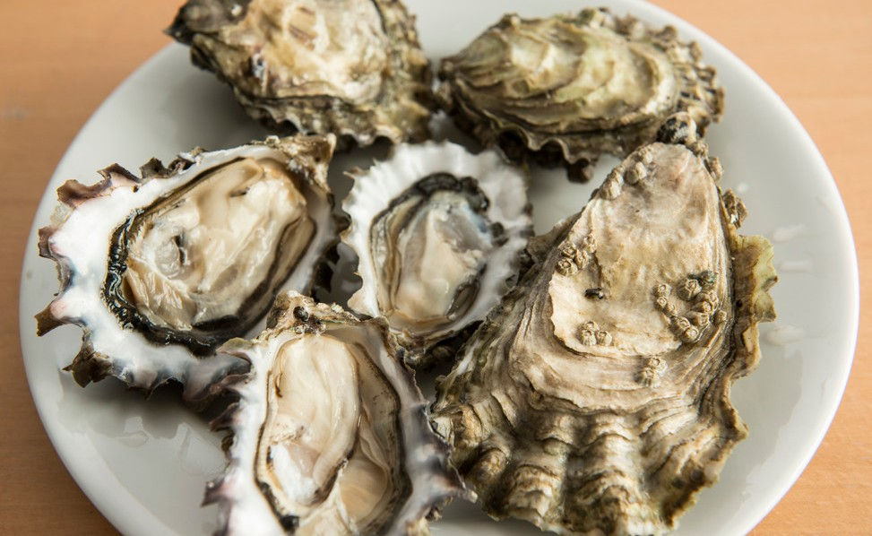
competitive marketing strategy and contribute to future growth plans.

ELEMENTS OF A SWOT ANALYSIS
SWOT Analysis = Core Business Tool
The key elements of a SWOT analysis are the identified internal strengths and weakness of the company and its product(s) and the external opportunities and threats that do, or could, affect the businesses ability to capture market opportunities.

The most effective way for a company to conduct a SWOT analysis is to list key strengths, weaknesses, opportunities and threats in a table as outlined below.

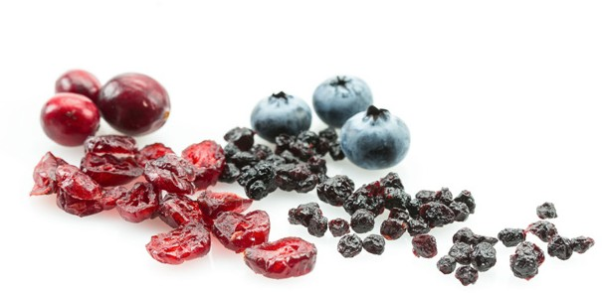

INTERNAL | STRENGTHS  Capabilities, resources or attributes that provide a competitive advantage  Examples: production capacity, industry experience, financial resources, unique ingredients or packaging | WEAKNESSES  Capabilities, resources or attributes that need improvement  Examples: lack of resources, limited experience, no marketing plan, no food safety or traceability  program
EXTERNAL | OPPORTUNITIES  Circumstances that if capitalized on could have a positive impact on the business  Examples: favourable market trends, new technology, government policy changes, potential partnerships | THREATS  Circumstances that do or could have a negative impact on the business  Examples: regulatory changes; new trends, access to ingredients, exchange rate fluctuations

A SWOT analysis can be used at any stage of your business. Doing an inventory of internal strengths and weaknesses and external opportunities and threats can help reveal solutions to problems and help clarify courses of action. Conducting a SWOT on a
HOW TO CONDUCT AND USE A SWOT ANALYSIS
BC Ministr y of Agriculture Marketing Guide Series
WHEN TO USE A SWOT ANALYSIS
Determine Where You Are at
and Where You Can Go
semi-annual basis is highly recommended.

SWOT ANALYSIS STEPS
- Create a SWOT team: include people responsible for decision making. The team can be small or large; the bigger the group, the more information you will obtain. Including someone from outside the company can provide a new perspective.

- Pick a leader, someone who is good at listening and facilitating groups, and a recorder. This can be the same person if the group is small. For larger groups it is helpful to have a recorder that can back up the leader. Use a flip chart or white board to record the discussion.

- Introduce the SWOT analysis tool to the group and explain why it is being used. The leader can explain that the SWOT analysis is used to determine where the company is at, and where it can go. If necessary, use an example to help team members understand the process and goals.

- Brainstorm and come up with strengths, weaknesses, opportunities and threats.
If the group is large, break into smaller groups, brainstorm and reconvene to share results.
- Discuss and record results. Reach consensus about the most important findings in each category. Compare the results to the company vision, mission and goals. Create action plans and strategies based on the SWOT analysis.

- Summarize the SWOT analysis in a report to use for strategic planning.

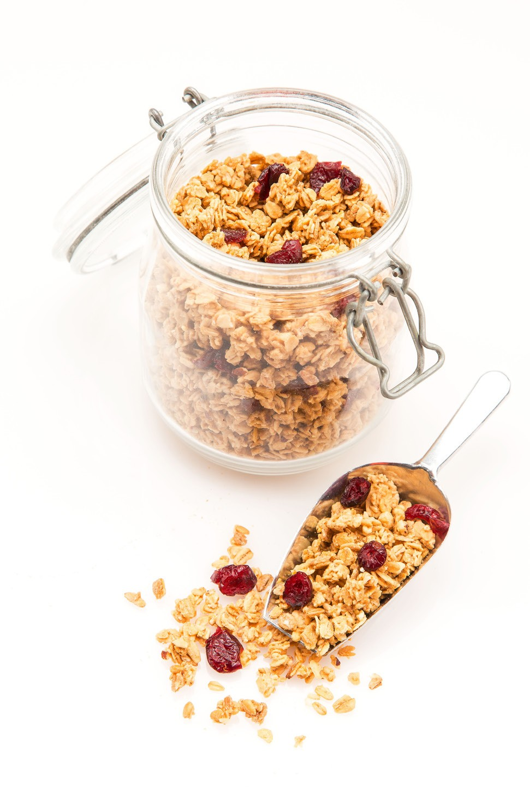

The purpose of a SWOT is to identify the positive characteristics of your business and the market and the real and potential problems that need to be recognized and/or addressed.
HOW TO CONDUCT AND USE A SWOT ANALYSIS
BC Ministr y of Agriculture Marketing Guide Series
HOW TO USE A SWOT ANALYSIS
A SWOT is a Living Document
Tip
Your SWOT also offers an
excellent way to organize
information gathered from
market research as well as a
simple way of communicating
your strategy.

To use the information in your SWOT table focus on leveraging strengths to address weaknesses so that you can minimize the risks of the threats and take advantage of the
opportunities. An example of how to conduct and use a SWOT analysis is on page 4 of this guide.

SHELF LIFE OF A SWOT ANALYSIS
A SWOT analysis is a living document. It should be reviewed and updated at least on a
semi-annual basis and whenever circumstances for the business change.

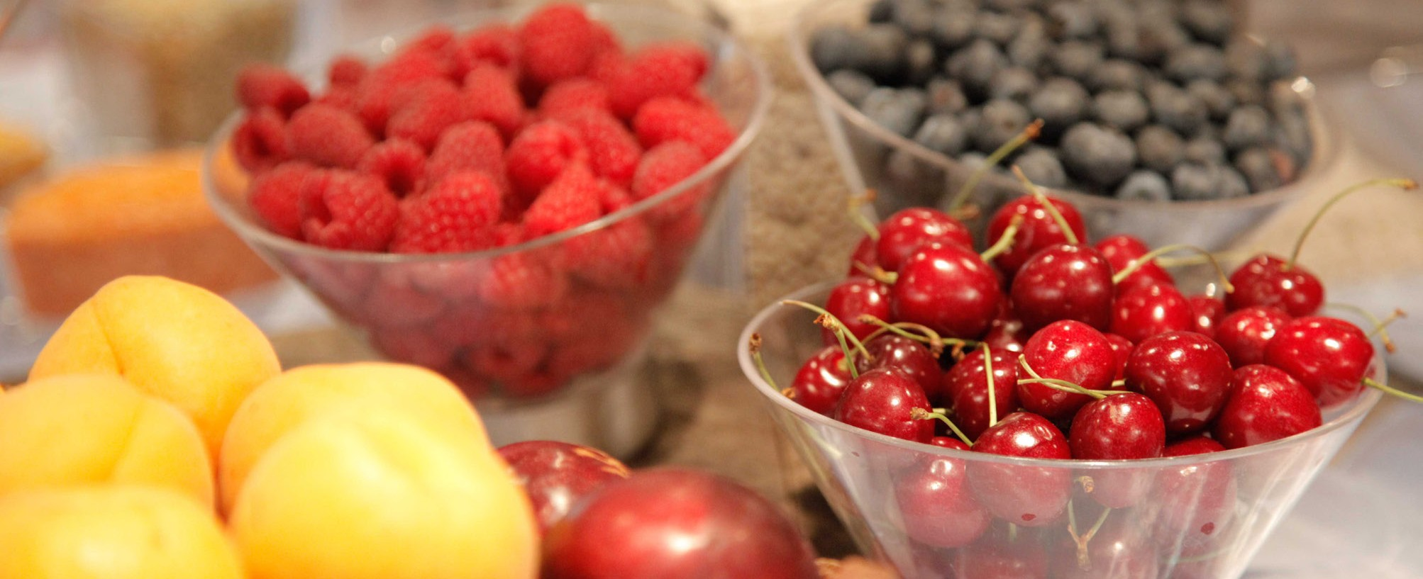

MORE INFORMATION
See the Ministry of Agriculture’s Marketing Guide Series for more information and additional topics by visiting http://www2.gov.bc.ca/gov/content/industry/agriculture-seafood/statistics/market-analysis- and-trade-statistics
The Government of Canada, the BC Ministry of Agriculture, and its directors, agents, employees, or contractors will not be liable for any claims, damages, or losses of any kind whatsoever arising out of the use of, or reliance upon, this information.

This example is based on the fictitious Company ABC, a new business that produces a gluten-free cookie made with ancient grains. The company’s goal is to become the largest manufacturer of healthy cookies on Vancouver Island. Company ABC’s SWOT table lists key strengths, weaknesses, opportunities and threats for illustrative purposes.

HOW TO CONDUCT AND USE A SWOT ANALYSIS
BC Ministr y of Agriculture Marketing Guide Series

EXAMPLE SWOT ANALYSIS

STRENGTHS | WEAKNESSES
Company:  - Food science expertise  - Sales have increased 57% in past six months  - Low rent due to location (Tofino)  - Utilizing low cost, approved, gluten-free, shared commercial kitchen*  Product:  - Contains less sugar and more protein than competitive products  - Is on-trend (gluten-free, locally made)  - Is listed in local food stores | Company:  - Lack of financing  - Has no business or marketing plan  - High distribution cost due to location  - Utilizing shared commercial kitchen limits production capacity*  Product:  - Higher priced than competitive products  - High ingredient costs  - Three month shelf life insufficient for retail sales
OPPORTUNITIES | THREATS
Company:  - High number of people with gluten sensitivities on Vancouver Island  - A higher volume in online purchases of natural health food products all over British Columbia | Company:  - CFIA’s Food Labelling Modernization Initiative may impact the company  - Trend for gluten-free on downturn  - Crop failure has affected supply of the ancient grains
*Note that a strength can also be a weakness. In this example the cookies are produced in a low cost shared commercial kitchen, meeting food safety requirements and gluten-free status. While a strength for a newly established company, it is also a weakness in that production in a shared commercial kitchen limits production capacity.

Using the information collected in the SWOT analysis Company ABC could use its food science expertise to reformulate lower cost cookies, and/or develop and market new healthy cookies based on science. Developing shelf stable gluten-free cookies would increase opportunities for retail sales and e-commerce. Increasing sales, product listings, partnership opportunities can be leveraged to access financing and marketing expertise. Knowing what the threats are allows
Company ABC to plan for labelling changes, the development of new products that are on trend and are made with more reliably sourced ingredients.

