Goshen Master Plan Update January 31, 2011

SWOT Analysis Report

Introduction
A Strengths, Weaknesses, Opportunities, and Threats (SWOT) Analysis is a strategic planning tool to evaluate internal and external influences upon a common vision or specific goal. SWOT analyses are a common method for a company or organization to assess its capacity to execute a plan or achieve an attainable goal. In the context of municipal planning the SWOT analysis evaluates the internal and external factors of a community (e.g.: quality of community services, external development pressures, internal attitudes toward commercial development, etc.) as they may pertain to the community values as reflected in the Vision Statement and Master Plan Goals as summarized below.

General Statement of Goshen’s Vision
In 2009 the Planning Board developed the following Vision Statement:
“Over the next ten years, Goshen will remain a small, rural residential community, with quiet, uncrowded living conditions, a healthy environment, and a vibrant small town atmosphere. Managed growth will result in buildings, roads, and public facilities that are well-maintained and scenic beauty that is undiminished.”
Additionally, the Planning Board developed the following Master Plan Goals:
- To preserve and enhance the small town character of Goshen and the open, rural character of the land.
- To provide efficient and effective town services and recreational opportunities, at a level that is consistent with the ability of the community to pay for them.
- To preserve and promote the appropriate use of existing historic properties and areas, such as the town center, historic houses, town cemeteries, and the Pierce Lead Mine; and to enable citizens to understand and appreciate the early history and development of Goshen.
- To adopt land use planning practices that preserve steep slopes, important soils, and other natural and built features to ensure that growth occurs in an orderly manner that will maintain the rural and scenic character of the community.
- To preserve and foster Goshen’s natural, scenic, and recreational resources, including surface waters, aquifers, wetlands, parks, agricultural land, open unfragmented land and public access.
- Provide for a vibrant community by allowing a diversity of housing within the village area integrated with appropriate nonresidential development that includes eating establishments, offices, home-based businesses, and arts and crafts studios.
- Maintain a sustainable community through energy conservation, alternative energy efforts, recycling, and proper disposal of household and hazardous waste.

Page 1

Goshen Master Plan Transportation Report January 31, 2011

SWOT Analysis Chart
The SWOT Analysis is a quick summary of internal and external influences on the community vision in a four-quadrant table. The following summary table of the SWOT analysis should be used as guidance to recognize how the identified influences can affect the pending planning process in the near future.

INTERNAL INFLUENCE EXTERNAL INFLUENCE
Strengths:  - Small town, quiet rural lifestyle  - Outdoor recreation  - Support for town services (fire, police, highway, school)  - Rural character  - Natural resources  - Undeveloped slopes and ridgelines (scenic value)  - Good public participation  - Limited infrastructure to maintain (e.g.: low road miles)  - Low cost housing relative to the region  - Local investment in land conservation  - Strong identity  - Support for home-based businesses  - Strong interest in residential development along existing roads  - Village center is important community asset | Opportunities:  - Trails could be integrated into one town-wide system  - Community support for diversity of housing options in the Village  - Mount Sunapee State Park  - Center and Lempster Coach Roads offer scenic byway designation options  - Broadband mapping program  - Potential access to small-scale hydro- power generation  - Cluster residential development to preserve open space, ridgelines, and wildlife habitat  - Minimal development pressure at present (opportunity to plan for future)  - Support for outdoor recreation  - Business development in specific areas  - Goshen Grange Hall may serve municipal facility needs  - Strong regional employment trends
Weaknesses:  - Recreation trails not marked, no consistent trail network  - No Capital Improvement Program to plan and budget for major capital expenditures  - No sidewalks in the Village  - No water/sewer infrastructure  - Limited suitable land for commercial development  - Degrading Fire Station and Highway Garage facilities require substantial renovations  - Town hall storage and office space is insufficient, unsafe, and does not  allow handicap access | Threats:  - Limited public transportation options  - Increased population will increase demand on services and community facilities  - Limited broadband access  - Large commercial developments  - Large residential developments  - Global competition with local agriculture  - Erosion along Sugar River may affect Fire Department property

POSITIVE IMPACT

NEGATIVE IMPACT

Page 2

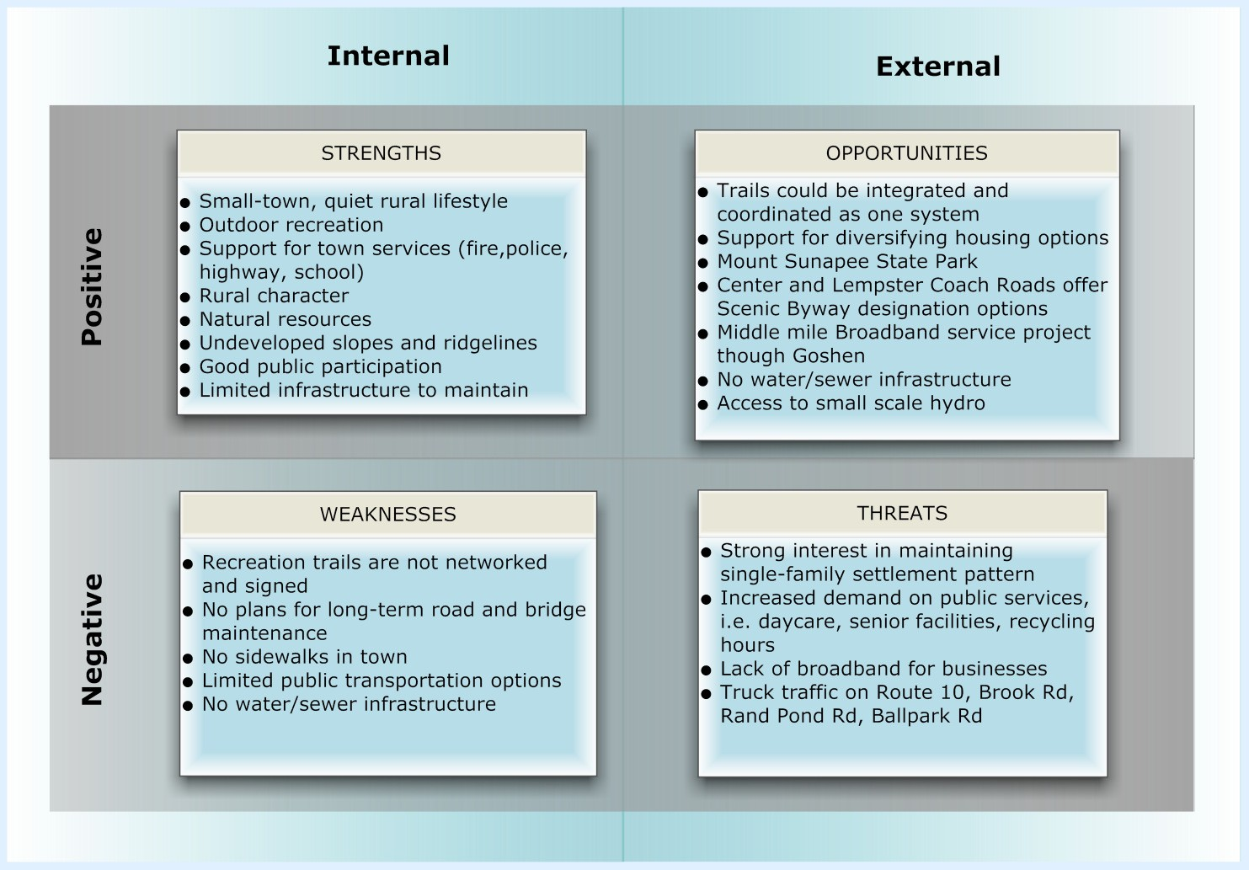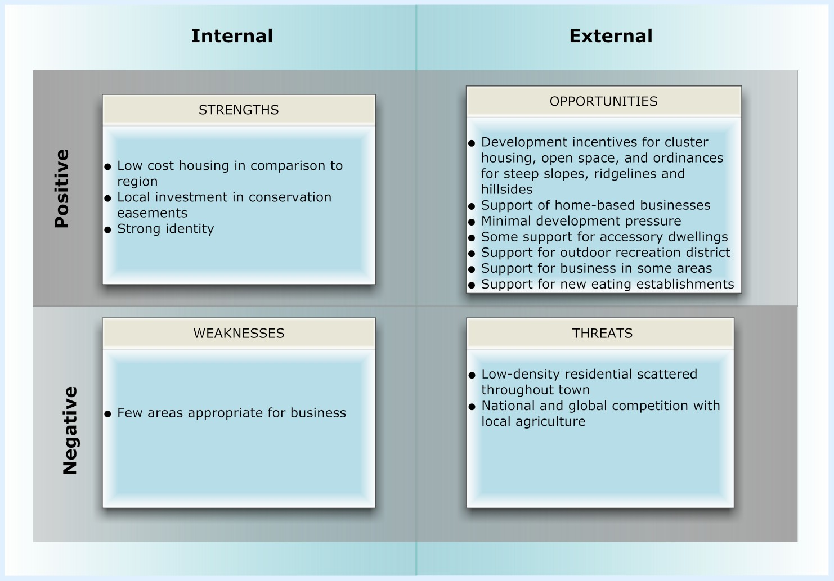SWOT Analysis
Positive
Negative
Negative
Positive

Internal
External

Internal
External

