WANTED
THE CRUCIBLE
Poster project
WHO IS TO BLAME?

WANTED

Description:
Charged with:

Teacher Guide
Thank you for purchasing this product! Please leave a review for my records and let me know the positives and possible improvements so I can better serve your needs!

~*Follow me for great deals*~

Polished, practiced, and
professional
©2014

Teacher Guide
Instruction:
Who was REALLY responsible for the Salem Witch Trials? This fun activity gives your students an alternative view on who could be to blame for the happenings of the trials, as well as getting creative with drawing and stating their character’s case. The students are to create Wanted posters for their character. The best way this lesson can be taught is to divide your class into ten groups. They are to create a Wanted Poster for their character, describing specific characteristics (physical, who they can be seen with, where they can be located, etc) as well as a list of charges. It might be beneficial to create a brainstorming activity within their groups about things they did during the play that could put them at fault for the Crucible. The Wanted Posters make great wall art and a great reminder to the students that there is always another view to who is to blame!

I have included templates of each character, as well as a blank template if you wish to do something else with this lesson. Also, a filled out page is included to show what kind of results are expected from this assignment. Do not mind the photo- it is just an example. ☺

If you have any questions, feel free to contact me in the Q&A portion of my TpT store. http://www.teacherspayteachers.com/Store/Iteacher-Lady-High- School-Ela

Thank you! iTeacher Lady

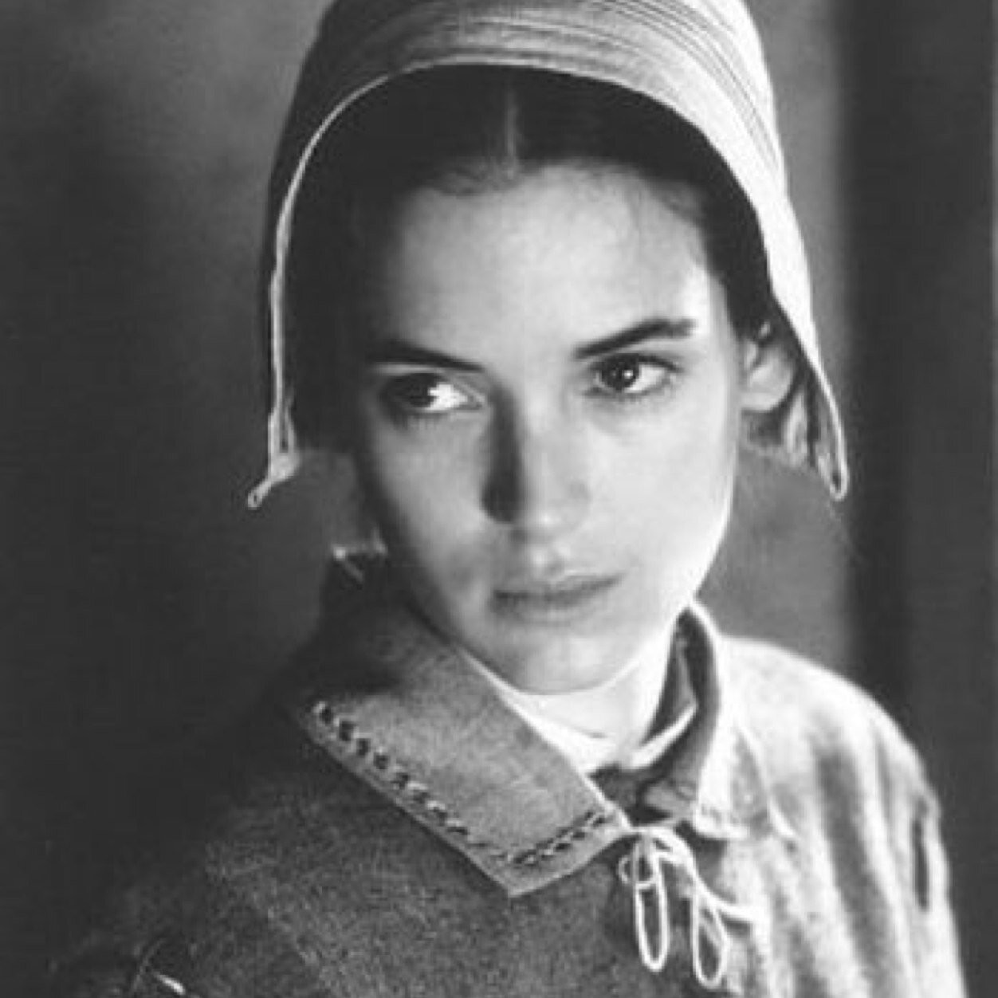
WANTED

Abigail Williams
Description: 17 year old girl. Strikingly beautiful, orphaned. Unusually strong willed. Full of passion. Usually surrounded by a group of girls.
Charged with: Murder (multiple counts), attempted murder (Elizabeth Proctor), theft (Reverend Parris), perjury, dancing in the woods, and animal cruelty (drinking chicken blood).

WANTED

Abigail Williams
Description:
Charged with:

WANTED

John proctor
Description:
Charged with:

WANTED

Reverend parris
Description:
Charged with:

WANTED

Reverend hale
Description:
Charged with:

WANTED

Thomas putnam
Description:
Charged with:

WANTED

Mary warren
Description:
Charged with:

WANTED

Elizabeth proctor
Description:
Charged with:

WANTED

tituba
Description:
Charged with:

WANTED

Judge danforth
Description:
Charged with:

WANTED

Giles corey
Description:
Charged with:

