Sample Profit and Loss Statement for Self–Employed Homeowners
Note: This is a sample template to be used as a guide for homeowners. Depending on your business, you may be asked to provide additional information.
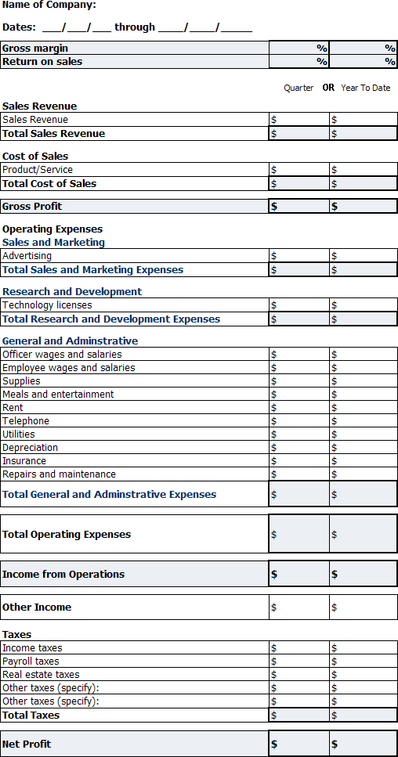

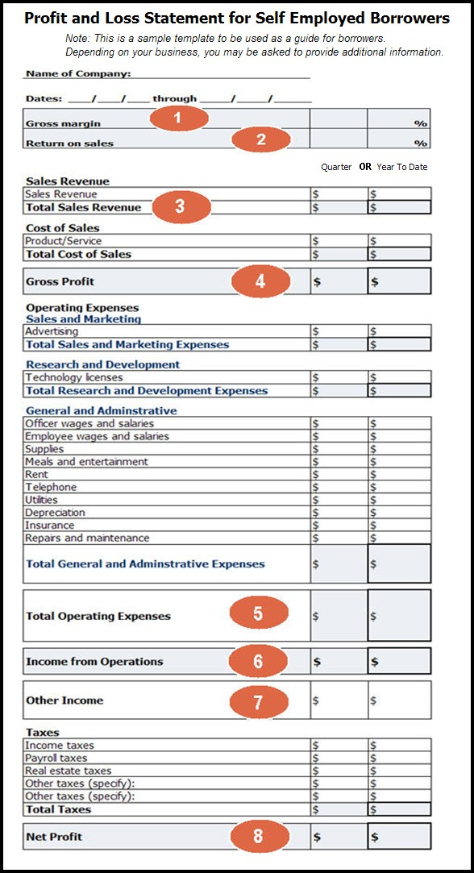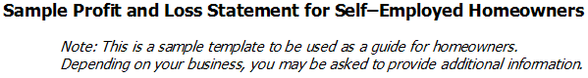Instructions for Completing Sample Profit and Loss Statement for Self‐Employed Homeowners

The numbered sections correspond to the definitions below. Please note that the numbered order of the definitions is not necessarily the order in which the form should be completed.

In the columns, provide either your most recent Quarterly or Year‐to‐date numbers

- Gross Margin = (Gross Profit) / (Total Sales Revenue)
- Return on Sales = (Net Profit) / (Total Sales Revenue)
- Total Sales Revenue = All Income from Sales or Services. All money collected from the work you have done.
- Gross Profit = (Total Sales Revenue) ‐ (Total Cost of Sales)
- Total Operating Expenses = (Total Sales and Marketing Expenses) + (Total Research and Development Expenses) + (Total General and Administrative Expenses)
- Income from Operations = (Gross Profit) ‐ (Total Operating Expenses)
- Examples of Other Income includes: bad debts recovered, interest, tax refunds and other miscellaneous business income
- Net Profit = (Income from Operations) + (Other Income) ‐ (Total Taxes)

