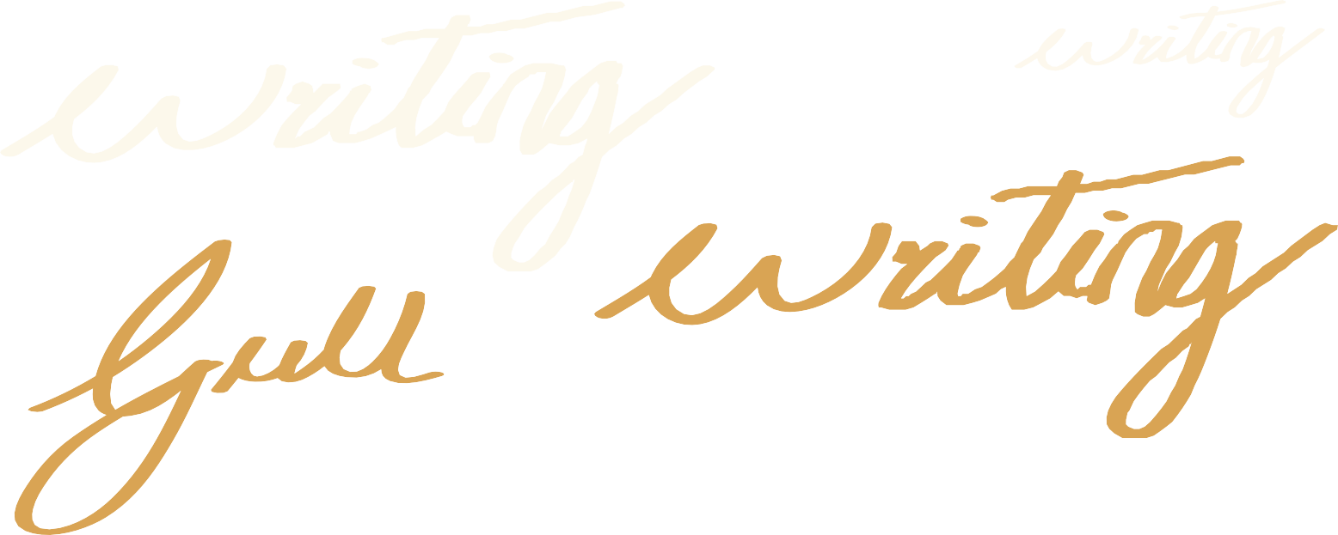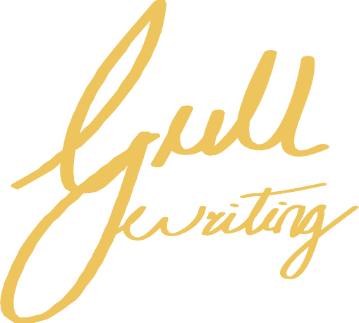Improve yourself and your business
Advance your career, train staff, learn new management techniques
Home | Business Manuals | Tourism Manuals | Contact Us

Business Management & Training Series
How To

Write Training Manuals
By Rob Tonge

HOME | Business Manuals | Tourism Manuals | Contact Us

Thank you for downloading the sample chapters of How To Write Training Manuals published by Gull Publishing.This excerpt includes the Table of Contents and the first chapter, which overviews the book.
We hope you find this information useful in evaluating this book.

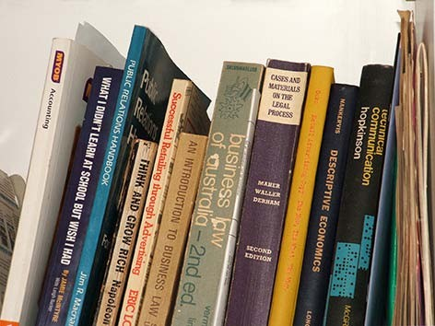To order visit: www.e-trainingmanuals.com.au
© Rob Tonge, 1992, 1993, 1995, 1996, 2001, 2006, 2008, 2010

First published 1992
Second edition 1993
Third edition 1995
Fourth edition 1996
Fifth edition 2001
Sixth edition 2006
Seventh edition 2008
Eighth edition 2010

GULL PUBLISHING PTY LTD
PO BOX 2,6 COOLUM BEACH, QUEENSLAND 4573 AUSTRALIA ISBN 978 1 876834 36 4

www.e-trainingmanuals.com.

Design and typesetting by Ad Image www.adimage.net.au

This manual is Copyright. With the exception of worksheets, no other part of this publication may be reproduced, stored in a retrieval system or transmitted in any form or by any means, electronic, photocopying, recording or otherwise, without prior written permission. Enquiries should be directed to the publisher.

DISCLAIMER
This manual is provided to purchasers with the express knowledge and understanding that Gull Publishing Pty Ltd, its authors, directors, shareholders, agents and employees, the producers of the manual or any approved person working on behalf of these companies (hereafter referred to as ‘the Company and Agents’) will not be responsible or in any way liable for the results of any act done or omitted to be done on the basis of information contained in this manual, nor for any errors or omissions in the said information. The Company and Agents expressly disclaim all and any liability for any loss or damage which may be suffered by any person or corporate entity which may make use of this manual or any person arising our of or as a result of or in connection with any act done or omitted to be done by the person using the manual in reliance, whether whole or partial, upon the whole or any part of the contents of this manual whether that loss/damage is caused by any fault or negligence on the part of the Company and Agents, or otherwise howsoever.

HOME | Business Manuals | Tourism Manuals | Contact Us

CHAPTER 1:

"Introduction" 5
What is a Manual? 5
Common Errors in Writing Manuals 6
Three Fundamental Rules 7
CHAPTER 2:
"How To Plan The Manual" 8
The Eight Benefits of Planning 8
The Planning Process – Flow Chart 9
Worksheet #1 13
CHAPTER 3
"Getting The Message Across" 15
Accuracy 15
Brevity 15
Clarity 16
Provide the Right Level of Information 16
Involve the Reader 17
Develop Flow Charts & Checklists 18
Write Authoritatively 18
Deliver the Promises 19
How Long Will the Information Remain Current? 19
Length of the Text 19
CHAPTER 4:
"Writing The Manual" 20
Eight Ways to Improve Writing Skills 20
Overcoming Writer’s Block 23
Recommended References 23
CHAPTER 5:
"Illustrations" 24
How Illustrations Should be Used 24
Types of Illustrations 24
Captions 26
Worksheet #2 26
CHAPTER 6:
"Permissions, Copyright And Moral Rights" 28
Obtaining Permission to Use Copyright Material 29
Permission Request Letter 29
Moral Rights 30
CHAPTER 7:
"How To Prepare the Preliminary Pages & End Matter" 31
Preliminary Pages 31
End Matter 32
CHAPTER 8:
"Editing And Proofreading" 33
Rewriting & Editing the Draft 33
Grammatical Myths 34
Avoiding Sexist or Discriminatory Language 34
Checking the Sequence of Information 34
Establishing the Heading Hierarchy 34
Checking the Positioning of Illustrations 34
Highlighting Important Words & Phrases 35
Numbering Headings & Text 35
Proofreading 35
Checking the Spelling 35
The Seven Cs of a Good Manuscript 36
CHAPTER 9:
HOME | Business Manuals | Tourism Manuals | Contact Us

"How To Determine An Appropriate Layout" 37
Determine the Environment in Which the Manual Will be Used 37
Layout Decisions – Flow Chart 38
Format 39
Division into Parts or Main Sections 39
Foldout Sheets 39
Checklist Positioning 40
Quick Reference Sheets/Cards 40
Page Amendment Flexibility 40
Page Layout 41
Type Style & Size 42
CHAPTER 10:
"How To Prepare the Final Manuscript for Production" 44
Finalise the Title 44
Prepare Specifications for Typing 44
Prepare an Index (If Appropriate) 44
Prepare the Contents Page 45
The Final Proofread 45
Prepare Specifications for Production 45
CHAPTER 11:
"How To Produce The Manual" 47
Printing 47
Photocopying 47
Single or Double-Sided Reproduction 49
Covers 49
Binding 50
Legal Deposit Requirements 51
CHAPTER 12:
"Managing A Team Writing Project" 52
Preparing the Project Timetable 53
Briefing the Team 53
Project Management – Flow Chart 54
Avoiding Unnecessary Paperwork 55
Follow-Up & Monitoring Process 55
Avoiding Potential Problems in Collaborative Writing Projects 55
CHAPTER 13:
"Self-Publishing Manuals For Profit - How To Analyse The Opportunity And Market Potential" 57
Five Key Questions 57
The Market Analysis Process 58
Market Analysis Process – Flow Chart 59
The Interrelationship of the Market Analysis Steps 63
How to Conduct Surveys to Obtain Information for the Project 64
"Check List" 65

HOME | Business Manuals | Tourism Manuals | Contact Us

hroughout every facet of business and society today, the demand for specialised information is insatiable. Advances in technology, the requirement for greater efficiency and productivity, an expanding range of community services, and the focus on training, are just some of the factors creating a growing need for ‘how to’ manuals on a wide range of
CHAPTER ONE
T
subjects.
This is resulting in more and more organisations calling upon staff to write this type of publication for in-house use.Also, the need for ‘how to’ information in the form of manuals is creating new opportunities in the field of self-publishing.
For self-publishers, the best potential lies in the sector of the book trade that tends to be bypassed by major publishers. This is the highly specialised information that is produced in short-print runs for equally specialised niche readership markets, and is not normally available in bookshops.
The aim of this manual therefore is to assist those who are involved in writing training or other ‘how to’ manuals on any subject, to produce effective, clear, concise and well- presented publications in any private or public sector organisation.
The principles described can be applied:
- By trainers who prepare manuals, workbooks and other material for training programs;
- By staff members tasked with preparing a manual for in-house use;
- By anyone intending to write a manual as a commercial, non-fiction, self-publishing venture; and
- By those involved in team or collaborative writing projects.
The following chapters show how to develop the initial idea or concept through each of the stages of planning, writing, editing, preparing the manuscript for publication, and production. They also describe how to conduct basic research to locate and assess competitive publications, how to identify an information gap (opportunity), how to determine the market potential, and how to identify the needs of end-users
Basic flow charts are included in appropriate chapters, and a master checklist covering the entire process from idea to completed publication is given in the final section.
By the time you have worked through each chapter you should have a thorough understanding of all the issues involved to enable you to write a manual which is easy to comprehend, provides information at the right level, and keeps readers interested from the first to the last page.

WHAT IS A MANUAL?
A manual is defined as a book of information or instruction. It is generally perceived as a publication that is shorter than a ‘book’ in the accepted sense, and produced with plastic comb/coil binding or in ring binders.

HOME | Business Manuals | Tourism Manuals | Contact Us

In the context of this particular publication, the term ‘manual’ refers to:
  - Training manuals
  - Staff instruction manuals
  - Policy & procedures manuals
  - General ‘how to’ manuals
  - Reference manuals
  - Technical manuals
  - Operation manuals
  - User guides
… and any other form of user documentation.

COMMON ERRORS IN WRITING MANUALS
Although much greater emphasis has been placed on communication skills in recent years, many manuals published today are laborious to read, difficult to comprehend, fail to provide a practical approach, and are poorly set out. Frequently, the level of information is well above the reader’s requirements because these writers persist in giving the style and level of information they think is needed. Rarely is the end-user clearly identified, much less the real information needs of the target readership.
These are the findings of extensive research conducted by our organisation into the effectiveness of different types of training and instruction manuals. They are also based on discussions held over a period of two decades with hundreds of end-users and many target readership groups in both the private and public sectors.
There are four main reasons why these problems occur:
- Insufficient consideration is given to the need for clarity in transferring information to the reader in a manner that ensures the message cannot be misunderstood. In other words, seeing it from the reader’s viewpoint.
- Traditional methods taught in the education system, particularly at tertiary level, tend to place emphasis on a more formal ‘academic’ style of writing, with the result that many people believe this is the way all manuals should be written. This style is then perpetuated because intending writers see so much material continuing to be written this way.
- Writers employed by some organisations are frequently placed under tight (sometimes unreasonable) time constraints, with the result that insufficient consideration is given to planning, style and layout. The writing project is viewed simply as ‘getting it written and produced in the shortest possible time’.
- Also in some organisations, after a final draft has been submitted to management for approval, there is often the tendency for several people at management level to ‘chop and change’ the text to align with their individual ideas on the way the manual should be written.This problem can also occur in team or collaborative writing projects.
Yet, as the pressures in every facet of society, business and daily life steadily mount, as new ways of doing things are being developed at an ever-increasing rate, and as we become bombarded with more and more information which must be absorbed in the shortest possible time, the need for good, clearly written communication has never been greater than it is today.

HOME | Business Manuals | Tourism Manuals | Contact Us

THREE FUNDAMENTAL RULES
The objectives of any information or instruction writing project are to motivate the end- user to:
  - Read the information;
  - Understand the information;
  - Apply the information; and
  - Remember the information.
If these objectives are to be achieved, three fundamental rules must be applied throughout the writing process:

- WRITE FOR THE END-USER
- KEEP IT SIMPLE
- KEEP IT CONCISE

These three rules comprise the foundation of good, clear writing and the effective transfer of information from writer to reader. These rules should be kept uppermost in mind throughout any writing project, whether it involves just one writer or a collaborative effort.

HOME | Business Manuals | Tourism Manuals | Contact Us

ommencing to write a manual without a clear plan to follow can be likened to driving to an unfamiliar destination without a road map. Similarly, sitting at a desk staring at a computer screen or a pile of blank paper, wondering just where to begin, can be a daunting
CHAPTER ONE
C
experience.
At this commencement stage, particularly in self-publishing ventures, writers invariably find they must do other jobs as a matter of urgency - jobs that have been ignored for months. Anything but starting the writing process.
This sudden burst of frenzied activity usually results from the lack of a writing plan, and sometimes the perception that it is necessary to start at the beginning and proceed through the manuscript to completion. While a few writers can work this way, the majority find that thoughts and ideas rarely occur in sequence.
Writing a manual is hard work, but instead of thinking about the task in its entirety, break the project down and think ‘bits of the book’. The starting point to get your thoughts and ideas in order is to develop a plan or framework for writing the text by following the steps shown in the chart on the following page, and explained in the balance of the chapter.

THE EIGHT BENEFITS OF PLANNING
The importance of planning the text cannot be over-emphasised. Effective planning produces eight benefits:

- Provides a clear path to follow;
- Saves time;
- Makes the writing process much easier;
- Identifies gaps in research;
- Establishes chapter headings and sub-headings before writing begins;
- Minimises the risk of overlooking information;
- Ensures the information flows in sequence through each chapter and throughout the entire manuscript; and
- Helps to overcome ‘writer’s block’.

HOME | Business Manuals | Tourism Manuals | Contact Us

THE PLANNING PROCESS
OBTAIN AN INTERNATIONAL STANDARD BOOK NUMBER (ISBN)
(Optional)
SET A DAILY WRITING TARGET
SELECT A TITLE
ORGANISE THE REFERENCE MATERIAL
- Identify & obtain additional references required
ARRANGE THE TOPICS IN LOGICAL SEQUENCE
DEVELOP THE CHAPTER TOPICS
ORGANISE THE CHAPTER SEQUENCE
IDENTIFY THE CHAPTER HEADINGS
DEFINE THE SUBJECT

HOME | Business Manuals | Tourism Manuals | Contact Us

Step 1: Define the Subject
If the information is to be conveyed with maximum clarity, you must first get the message clear in your own mind. You must also know the purpose of the message. So, the initial step in the planning phase is to define the subject.
To start writing without establishing this definition can mean that part-way through the manuscript you may find the scope is far too wide. This can result in the inclusion of information that is irrelevant.
The need for specialised information should be kept uppermost in mind.
Knowledge gained from the market analysis should indicate the topics to be covered and the appropriate approach to develop a definition of the subject. Write it down and endeavour to limit the definition to one sentence.
Depending on the subject, this task may not be quite as easy as it sounds. Spend the time to refine the definition until it is precise and clear in your mind.

Step 2: Identify the Chapter Headings
Having established the subject definition, the next step is to compile a list of the main subjects you intend to cover. These will be the chapter headings. Don’t try to arrange them in order at this stage, just concentrate on getting the headings down on paper.
When this exercise has been completed, carefully review the list and make sure you have not overlooked any particular main item.

Step 3: Organise the Chapter Sequence
After the initial list has been completed, rearrange these headings into logical sequence. It is usually necessary to rearrange the list several times.
When you are satisfied with the list, write each chapter heading on a new page, leaving a wide margin on the left-hand side.
Number these sheets to keep them in the same order as your list.
Obtain a Lever Arch file and as many index sheets as you have chapter headings. Insert the chapter heading sheets - one behind each index sheet.
Insert a master list of chapter headings in the front of the file.

Step 4: Develop the Chapter Topics
Take any chapter sheet, and list all the topics, thoughts and ideas you intend to cover in that particular chapter.
At this stage you may find it necessary to further rearrange the chapters; perhaps combining several and/or developing others. This process is an excellent thought-stimulator and invariably you will find additional points coming to mind that were initially overlooked.

Step 5: Arrange the Chapter Topics in Logical Sequence
Review each list of topics and rearrange them so the information flows through each chapter in the right order. Again it may be necessary to amalgamate topics or move them to other chapters
Steps 4 and 5 are the core of the planning process, therefore, it is essential to take the time to rearrange the material until you are satisfied with the subject matter and sequence of information
On completion of this refinement you should have a comprehensive outline or plan of the manual in the form of a number of chapter checklists..

HOME | Business Manuals | Tourism Manuals | Contact Us

Step 6: Organise the Reference Material
When researching and planning a publication, most writers collect a mass of reference material in the form of notes, articles, photocopied references and other assorted information.
This material should be organised into the same subjects as the chapter headings and then filed in separate Lever Arch files, or in an appropriate system that facilitates easy retrieval. As you organise this material, list any additional references that may be required, and take the necessary action to obtain this material.

Step 7: Select a Working Title
It is important to give some thought to the title during the planning process.
With some types of manuals, particularly those for in-house use, this may not be a problem, but for publications that are to be offered for sale to the public, the title requires careful consideration.
The best way to develop a title is to write down all the possibilities and select one that seems to be appropriate. Regard this as a working title because you may change it several times as you progress through the manuscript. Take heart - this changing of titles happens with all of us - and sometimes the final title decision may not be made until just before the manuscript goes into production.
The main point is to develop a working title at this early planning stage, because in most cases it makes it easier to decide the title under which the manual will eventually be published. As to the title length; when I was starting out in self-publishing, one ‘expert’ advised me never to use long titles - advice which in several instances I have studiously ignored.
The title should give a clear indication of the subject, or what the manual can do for the reader. For example, the title of two of our manuals ‘How to Become a Successful Consultant in Your Own Field’ and ‘How to Prepare a Tourism Development Plan for Your Community’, contain ten words and tell readers exactly what the subject is about. Both are very popular in the marketplace.
This is not to say that short, punchy titles do not have impact - they do. Furthermore, they are preferable. It largely depends on the subject and the need to get the message across to the potential reader or purchaser. There is, of course, a limit to title length. A too long title can be unwieldy, and unless carefully worded, can become confusing.
With some manuals it may be appropriate to use a main title with a sub-title, such as:
‘TELEPHONE TECHNIQUES’
One-Day Workshop Training Manual
Again, this method indicates to potential readers the subject and purpose of the manual. One way to develop a title is to ask yourself:
- What is the subject? (refer to the definition)
- What is the purpose of the manual?
- What benefits will the reader gain?

Most manuals describe how to do or achieve something.

HOME | Business Manuals | Tourism Manuals | Contact Us

From a commercial viewpoint it has long been recognised that the words ‘HOW TO’ have strong appeal in the marketplace. However, a word of caution; if you intend using a title with the words ‘How to . . . ’, the manual must do just that.
Authors who self-publish occasionally make the mistake of selecting a title that sounds good to them. Sometimes a title is chosen which bears little relation to the content, and is confusing. If the manual is to be a commercial venture, as with the content, you must approach the selection of a title from a marketing and readership viewpoint.

Step 8: Set a Writing Target
There are many people who intend to write a book or manual, but the manuscript never becomes a reality, because it is easy to procrastinate.
From my own experience writing many reports and manuals, and from discussions with other successful authors, I firmly believe that by far the best method of avoiding the procrastination problem is to set a daily writing target - setting your mind to writing a certain number of words each and every day until the manuscript is finished.
For self-publishers this last step in planning can be regarded as the ‘crunch’ because this is the point which invariably shows whether you are serious about getting into print.
But, setting the target is just part of the process. You must be able to exercise sufficient self-discipline to ensure the target is achieved. I will readily admit this is not always easy. I lead a busy life and when I started writing some years ago my target was only 100 words a day. Eventually I found I could increase this to 200, then 500 words. Today I aim for 700 words.
The important thing is to set a target that is achievable given other commitments and time constraints, even if it is just 50 words per day. If the target is unrealistic, procrastination will take over and the project will fall by the wayside.
Step 9: Obtain an International Standard Book Number (ISBN) (Optional)
Most publications to be widely distributed in the public arena carry an International Standard Book Number, known as an ISBN, which is shown on the Copyright page.
This number is not a legal requirement but provides the advantages of clearly identifying a particular publication, and having it included in the Australian Bibliographic Network database and the Australian National Bibliography (published annually). Both these bibliographies are used extensively by libraries for ordering purposes and by individuals and organisations for research and to locate publications on particular subjects.
Obtaining the ISBN is the responsibility of the publisher and is available from the ISBN Agency (part of the Thorpe Bowker Group) in Melbourne.
Information on the ISBN system and an application form are on the ISBN Agency website:
www.thorpe.com.au/isbn
An ISBN can be obtained by any individual, group or organisation responsible for originating (writing/publishing) a publication, but not the printer. Like most things these days, getting an ISBN involves a cost.
The ISBN can be obtained early in the project - in the planning phase if you wish. However, the ISBN Agency prefers publication to take place within 3-6 months of allocating a number.

HOME | Business Manuals | Tourism Manuals | Contact Us

Although a title itself cannot be copyrighted, having an ISBN and a title on record can deter other authors from using a similar title or perhaps writing a similar publication.
If required, an ISBN can be obtained on the basis of just a working title. The ISBN Agency can then be advised of the final title prior to production, without any change in the number, provided the publisher does not change.

WORKSHEET #1
The following page provides a worksheet. Photocopy this sheet, and in the spaces provided, write in:
- the subject definition;
- the working title;
- the daily writing target;
then place this sheet where you can see it at all times while writing the manual. This will help you keep the project on-track throughout the writing process.

HOME | Business Manuals | Tourism Manuals | Contact Us

SUBJECT DEFINITION:

WORKSHEET #1

WORKING TITLE:

DAILY WRITING TARGET:

WORDS

WRITE FOR THE END-USER KEEP IT SIMPLE
KEEP IT CONCISE

HOME | Business Manuals | Tourism Manuals | Contact Us

OTHER PRACTICAL MANUALS AVAILABLE

TOURISM MANAGEMENT SERIES:
- How to Establish & Operate a Visitor Information Centre
- How to Organise Special Events & Festivals
- How to Prepare a Tourism Development Plan for Your Community
- How to Conduct Feasibility Studies for Tourism Projects
- How to Advertise & Promote Tourism Businesses
- How to Establish Host Farm Ventures
- How to Publish Profitable Tourist Guidebooks
- How to Gain Free Media Exposure to Promote Your Tourism Business
- Achieving Financial Success in Motels
- Achieving Financial Success in Restaurants & Café Bars
- How to Control the Risks in Tourism Investment

BUSINESS MANAGEMENT & TRAINING SERIES:
- How to Become a Successful Consultant in Your Own Field
- How to Write a Consultancy Brief & Select the Right Consultant
- How to Write Information & Instruction Manuals
- How to Develop & Write Job Descriptions
- How to Prepare Effective Applications for Grant Funding
- Flow Charts & Checklists for Managers, Supervisors & Trainers
- How to Prepare for & Conduct Staff Selection Interviews
- How to Achieve Customer Service Excellence
- How to Power Profits in Cafés & Restaurants

For details and prices of all our publications visit our Website: www.gullpublishing.com
To order visit: www.e-trainingmanuals.com.au
For further information phone (07) 5446 1318 or email: sales@e-trainingmanuals.com.au

