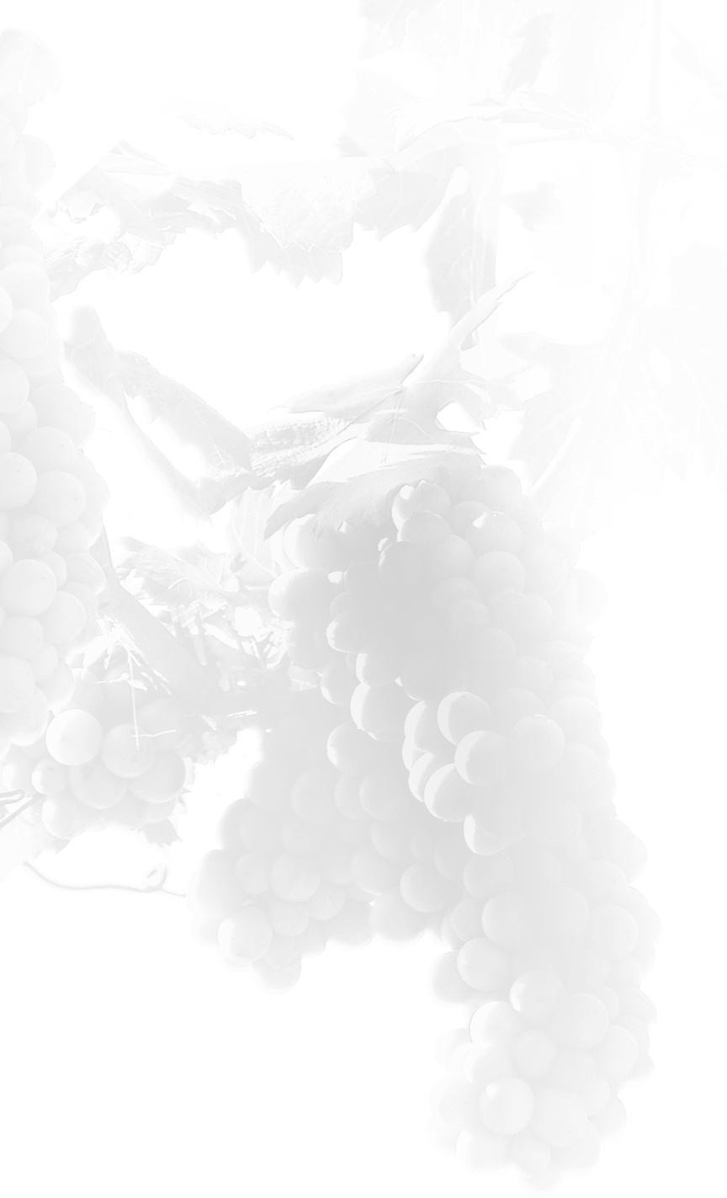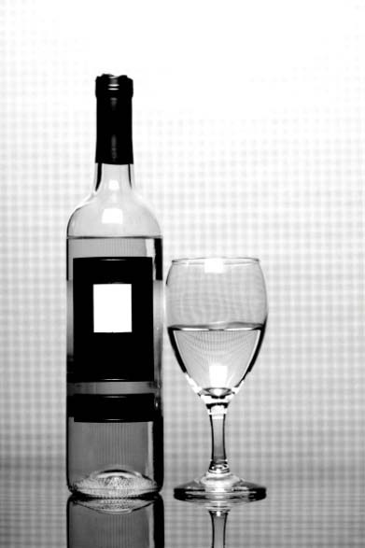

GUIDELINES FOR LABELING
Wine With Organic References

TTB P 5190.11 for Organic Wine Labeling - rev. 6/2009

GUIDELINES FOR LABELING WINE AS “100% ORGANIC”

This document contains a sample label. It should be used as guidance relating to the National Organic Program (NOP) regulations at 7 CFR part 205. To view these regulations in their entirety, please visit the United States Department of Agriculture's website at www.ams.usda.gov/nop. This sample complies with the Federal Alcohol Administration Act, the Alcohol Beverage Labeling Act and the NOP.

When labeling your product as “100% Organic,” it must contain 100 percent organically produced ingredients and have been processed using organically produced processing aids, not counting added water and salt. You should also consider the following points in designing your label:

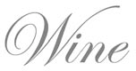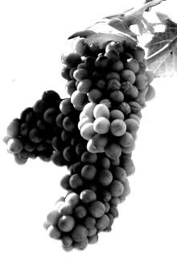BRAND NAME/CLASS & TYPE (OPTIONAL)
Grapeful
Or1g00a%nic

CALIFORNIA CABERNET SAUVIGNON
100%
Organically Grown Grapes
13.2% Alc./Vol.
750 ml
The phrase “100% Organic” may be used to modify the brand name and/or class and type statement on the PDP, IP, or OP.

SULFITE STATEMENT
“100% Organic” products cannot use added sulfites in production. Therefore, since no added sulfites are present in the finished product, the label may not require a sulfite statement. In these cases, a lab analysis is necessary to verify that the wine contains less than 10 ppm of sulfites.

INGREDIENT STATEMENT (OPTIONAL)
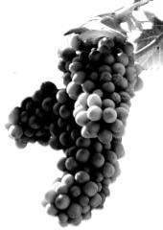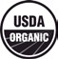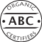Products certified as “100% Organic” may show a complete ingredient statement. The term “organic” may be used to identify the specific ingredients. Water and salt included as ingredients may not be identified as “organic.” This statement may only appear on the IP.
Grapeful
Organic
100%
PRODUCED & BOTTLED BY:
GRAPEFUL CELLARS, SOLIS, CA

CERTIFIED ORGANIC BY:
ABC Organic Certifiers
GOVERNMENT WARNING: (1) ACCORDING TO THE SURGEON GENERAL, WOMEN SHOULD NOT DRINK ALCOHOLIC BEVERAGES DURING PREGNANCY BECAUSE OF THE RISK OF BIRTH DEFECTS. (2) CONSUMPTION OF ALCOHOLIC BEVERAGES IMPAIRS YOUR ABILITY TO DRIVE A CAR OR OPERATE MACHINERY, AND MAY CAUSE HEALTH PROBLEMS.

CERTIFICATION STATEMENT (REQUIRED)
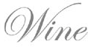
“Certified Organic by ---” or a similar phrase must be listed below the name and address of: the bottler, for domestic wines; or the bottler or importer for imported wines. This statement must be on the IP and may include the agent’s business address, telephone number, or internet address.

DEPARTMENT OF AGRICULTURE AGRICULTURAL MARKETING SERVICE WASHINGTON, DC 20250

DEPARTMENT OF THE TREASURY ALCOHOL AND TOBACCO TAX AND TRADE BUREAU
WASHINGTON, DC 20220

PDP - (PRINCIPAL DISPLAY PANEL) That part of
the label that is most likely to be displayed, presented, shown, or examined under customary conditions of display for sale.

IP - (INFORMATION PANEL) That part of the label of a packaged product that is immediately contiguous to and to the right of the principal display panel as observed by an individual facing the principal display panel, unless another section of the label is designated as the information panel because of package size or other attributes (e.g., irregular shape with one usable surface).

OP - (OTHER PANEL) Any panel other than the principal display panel, information panel, or ingredient statement.

IS - (INGREDIENT STATEMENT) The list of
ingredients contained in a product shown in their common and usual names in the descending order of predominance.
KEY

USDA ORGANIC SEAL (OPTIONAL)
The USDA Organic Seal may be placed on the label of a product that is certified as “100% Organic.” This seal may appear on the PDP, IP or OP.

CERTIFYING AGENT SEAL (OPTIONAL)
The seal of a USDA-accredited certifying agent may be placed on the label of a product that is certified as “100% Organic.” This seal may appear on the PDP, IP or OP.

GUIDELINES FOR LABELING WINE AS “ORGANIC”

This document contains a sample label. It should be used as guidance relating to the National Organic Program (NOP) regulations at 7 CFR part 205. To view these regulations in their entirety, please visit the United States Department of Agriculture's website at www.ams.usda.gov/nop. This sample complies with the Federal Alcohol Administration Act, the Alcohol Beverage Labeling Act and the NOP.

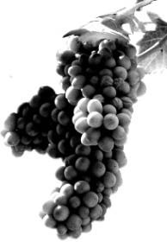When labeling your product as “Organic,” it must contain at least 95 percent organically produced ingredients, not counting added water and salt. In addition, your product must not contain added sulfites and may contain up to 5 percent non-organically produced agricultural ingredients allowed by 7 CFR 205.606 (provided your accredited certifying agent has determined the ingredients to be not commercially available in organic form), and/or other substances allowed by 7 CFR 205.605. You should also consider the following points in designing your label:
Organic
Grapeful
CALIFORNIA CABERNET SAUVIGNON
97% Organic

13.2% Alc./Vol.
750 ml

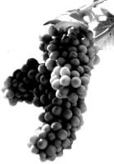BRAND NAME/CLASS & TYPE (OPTIONAL)
Grapeful
PRODUCED & BOTTLED BY: GRAPEFUL CELLARS, SOLIS, CA
Organic
CERTIFIED ORGANIC BY:
ABC Organic Certifiers
GOVERNMENT WARNING: (1) ACCORDING TO THE SURGEON GENERAL, WOMEN SHOULD NOT DRINK ALCOHOLIC BEVERAGES DURING PREGNANCY BECAUSE OF THE RISK OF BIRTH DEFECTS. (2) CONSUMPTION OF ALCOHOLIC BEVERAGES IMPAIRS YOUR ABILITY TO DRIVE A CAR OR OPERATE MACHINERY, AND MAY CAUSE HEALTH PROBLEMS.
The term “Organic” may be used to modify the brand name and/or class and type statement on the PDP, IP, or OP.

SULFITE STATEMENT
“Organic” products cannot use added sulfites in production. Therefore, since no added sulfites are present in the finished product, the label may not require a sulfite statement. In these cases, a lab analysis is necessary to verify that the wine contains less than 10 ppm of sulfites.

PERCENTAGE STATEMENT (OPTIONAL)
The phrase “X% Organic” or “X% Organic ingredients” may be included on the labeling. Such statements may appear on the PDP, IP or OP.

INGREDIENT STATEMENT (OPTIONAL)
Products certified as “organic” may show a complete ingredient statement. The term “organic” may be used to identify the specific ingredients. Water and salt included as ingredients may not be identified as “organic.” This statement may only appear on the IP.

CERTIFICATION STATEMENT (REQUIRED)
“Certified Organic by ---” or a similar phrase must be listed below the name and address of: the bottler, for domestic wines; or the bottler or importer for imported wines. This statement must be on the IP and may include the agent’s business address, telephone number, or internet address.

DEPARTMENT OF AGRICULTURE AGRICULTURAL MARKETING SERVICE WASHINGTON, DC 20250

DEPARTMENT OF THE TREASURY ALCOHOL AND TOBACCO TAX AND TRADE BUREAU
WASHINGTON, DC 20220
PDP - (PRINCIPAL DISPLAY PANEL) That part of
the label that is most likely to be displayed, presented, shown, or examined under customary conditions of display for sale.

IP - (INFORMATION PANEL) That part of the label of a packaged product that is immediately contiguous to and to the right of the principal display panel as observed by an individual facing the principal display panel, unless another section of the label is designated as the information panel because of package size or other attributes (e.g., irregular shape with one usable surface).

OP - (OTHER PANEL) Any panel other than the principal display panel, information panel, or ingredient statement.

IS - (INGREDIENT STATEMENT) The list of
ingredients contained in a product shown in their common and usual names in the descending order of predominance.
KEY

CERTIFYING AGENT SEAL (OPTIONAL)
The seal of a USDA-accredited certifying agent may be placed on the label of a product that is certified as “organic.” This seal may appear on the PDP, IP or OP.

USDA ORGANIC SEAL (OPTIONAL)
The USDA Organic Seal may be placed on the label of a product that is certified as “organic.” This seal may appear on the PDP, IP or OP.

GUIDELINES FOR LABELING WINE AS “MADE WITH ORGANIC INGREDIENTS”

This document contains a sample label. It should be used as guidance relating to the National Organic Program (NOP) regulations at 7 CFR part 205. To view these regulations in their entirety, please visit the United States Department of Agriculture's website at www.ams.usda.gov/nop. This sample complies with the Federal Alcohol Administration Act, the Alcohol Beverage Labeling Act and the NOP.

When labeling your product as “Made with Organic Ingredients” (or a similar phrase), it must contain at least 70 percent organically produced ingredients, not counting added water and salt. In addition, wine may contain added sulfites (in accordance with 7 CFR 205.605) and may contain up to 30 percent non-organically produced agricultural ingredients and/or other substances allowed by 7 CFR 205.605. You should also consider the following points in designing your label:
Grapeful
CALIFORNIA CABERNET SAUVIGNON

Made with Organic Grapes
13.2% Alc./Vol.
750 ml

“MADE WITH ORGANIC ---” STATEMENT (OPTIONAL)
The phrase “Made with Organic ---” (specified ingredients or food groups) may be included on the labeling. Such statements may appear on the PDP, IP or OP.

PERCENTAGE STATEMENT (OPTIONAL)
The phrase “X% Organic” or “X% Organic ingredients” may be included on the labeling. Such statements may appear on the PDP, IP or OP.

INGREDIENT STATEMENT (OPTIONAL)
Products certified as “Made with Organic Ingredients” may show a complete ingredient statement. The term “organic” may be used to identify the specific ingredients. Water and salt included as ingredients may not be identified as “organic.” This statement may only appear on the IP.

CERTIFICATION STATEMENT (REQUIRED)
“Certified Organic by ---” or a similar phrase must be listed below the name and address of: the bottler, for domestic wines; or the bottler or importer for imported wines. This statement must be on the IP and may include the agent’s business address, telephone number, or internet address.

DEPARTMENT OF AGRICULTURE AGRICULTURAL MARKETING SERVICE WASHINGTON, DC 20250

DEPARTMENT OF THE TREASURY ALCOHOL AND TOBACCO TAX AND TRADE BUREAU
WASHINGTON, DC 20220

PDP - (PRINCIPAL DISPLAY PANEL) That part of
the label that is most likely to be displayed, presented, shown, or examined under customary conditions of display for sale.

IP - (INFORMATION PANEL) That part of the label of a packaged product that is immediately contiguous to and to the right of the principal display panel as observed by an individual facing the principal display panel, unless another section of the label is designated as the information panel because of package size or other attributes (e.g., irregular shape with one usable surface).

OP - (OTHER PANEL) Any panel other than the principal display panel, information panel, or ingredient statement.

IS - (INGREDIENT STATEMENT) The list of
ingredients contained in a product shown in their common and usual names in the descending order of predominance.
KEY

CERTIFYING AGENT SEAL (OPTIONAL)
The seal of a USDA-accredited certifying agent may be placed on the label of a product that is certified as “Made with Organic Ingredients.” This seal may appear on the PDP, IP or OP.
Grapeful
75% Organic Ingredients

Ingredients: Organic Cabernet Sauvignon Grapes,
CONTAINS SULFITES

PRODUCED & BOTTLED BY:
GRAPEFUL CELLARS, SOLIS, CA

CERTIFIED ORGANIC BY:
ABC Organic Certifiers

GOVERNMENT WARNING: (1) ACCORDING TO THE SURGEON GENERAL, WOMEN SHOULD NOT DRINK ALCOHOLIC BEVERAGES DURING PREGNANCY BECAUSE OF THE RISK OF BIRTH DEFECTS. (2) CONSUMPTION OF ALCOHOLIC BEVERAGES IMPAIRS YOUR ABILITY TO DRIVE A CAR OR OPERATE MACHINERY, AND MAY CAUSE HEALTH PROBLEMS.

THE LABELS MUST NOT SHOW:

THE USDA ORGANIC SEAL

TTB P 5190.11 for Organic Wine Labeling

GUIDELINES FOR LABELING WINE AS “MADE WITH ORGANIC AND NON-ORGANIC INGREDIENTS”

This document contains a sample label. It should be used as guidance relating to the National Organic Program (NOP) regulations at 7 CFR part 205. To view these regulations in their entirety, please visit the United States Department of Agriculture's website at www.ams.usda.gov/nop. This sample complies with the Federal Alcohol Administration Act, the Alcohol Beverage Labeling Act and the NOP.
When labeling your product as “Made with Organic and Non-Organic Ingredients” (or a similar phrase), the label must indicate the presence of non-organic grapes in the “Made with Organic…” statement on the label, and such wine must contain at least 70 percent organically produced ingredients, not counting added water and salt. In addition, wine may contain added sulfites (in accordance with 7 CFR 205.605) and may contain up to 30 percent non-organically produced agricultural ingredients and/or other substances allowed by 7 CFR 205.605.
You should also consider the following points in designing your label:
Grapeful
CALIFORNIA CABERNET SAUVIGNON

Made with Organic Grapes & Non-Organic Grapes
13.2% Alc./Vol.
750 ml

“MADE WITH ORGANIC ---” STATEMENT (OPTIONAL)
The phrase “Made with Organic --- and Non- Organic ---” (specified ingredients or food groups) may be included on the labeling.
Such statements may appear on the PDP, IP or OP.

PERCENTAGE STATEMENT (OPTIONAL)
The phrase “X% Organic” or “X% Organic ingredients” may be included on the labeling. Such statements may appear on the PDP, IP or OP.

INGREDIENT STATEMENT (OPTIONAL)
Products certified as “Made with Organic Ingredients” may show a complete ingredient statement. The term “organic” may be used to identify the specific ingredients. Water and salt included as ingredients may not be identified as “organic.” This statement may only appear on the IP.

CERTIFICATION STATEMENT (REQUIRED)
“Certified Organic by ---” or a similar phrase must be listed below the name and address of: the bottler, for domestic wines; or the bottler or importer for imported wines. This statement must be on the IP and may include the agent’s business address, telephone number, or internet address.

DEPARTMENT OF AGRICULTURE AGRICULTURAL MARKETING SERVICE WASHINGTON, DC 20250

DEPARTMENT OF THE TREASURY ALCOHOL AND TOBACCO TAX AND TRADE BUREAU
WASHINGTON, DC 20220
PDP - (PRINCIPAL DISPLAY PANEL) That part of
the label that is most likely to be displayed, presented, shown, or examined under customary conditions of display for sale.

IP - (INFORMATION PANEL) That part of the label of a packaged product that is immediately contiguous to and to the right of the principal display panel as observed by an individual facing the principal display panel, unless another section of the label is designated as the information panel because of package size or other attributes (e.g., irregular shape with one usable surface).

OP - (OTHER PANEL) Any panel other than the principal display panel, information panel, or ingredient statement.

IS - (INGREDIENT STATEMENT) The list of
ingredients contained in a product shown in their common and usual names in the descending order of predominance.
KEY

CERTIFYING AGENT SEAL (OPTIONAL)
Grapeful
75% Organic Ingredients

Ingredients: Organic Cabernet Sauvignon Grapes, Merlot Grapes, CONTAINS SULFITES

PRODUCED & BOTTLED BY:
GRAPEFUL CELLARS, SOLIS, CA

CERTIFIED ORGANIC BY:
ABC Organic Certifiers

GOVERNMENT WARNING: (1) ACCORDING TO THE SURGEON GENERAL, WOMEN SHOULD NOT DRINK ALCOHOLIC BEVERAGES DURING PREGNANCY BECAUSE OF THE RISK OF BIRTH DEFECTS. (2) CONSUMPTION OF ALCOHOLIC BEVERAGES IMPAIRS YOUR ABILITY TO DRIVE A CAR OR OPERATE MACHINERY, AND MAY CAUSE HEALTH PROBLEMS.
The seal of a USDA-accredited certifying agent may be placed on the label of a product that is certified as “Made with Organic Ingredients.” This seal may appear on the PDP, IP or OP.

THE LABELS MUST NOT SHOW:

THE USDA ORGANIC SEAL

TTB P 5190.11 for Organic Wine Labeling

GUIDELINES FOR LABELING WINE RESTRICTED TO AN “ORGANIC INGREDIENTS” STATEMENT

This document contains a sample label. It should be used as guidance relating to the National Organic Program (NOP) regulations at 7 CFR part 205. To view these regulations in their entirety, please visit the United States Department of Agriculture's website at www.ams.usda.gov/nop. This sample complies with the Federal Alcohol Administration Act, the Alcohol Beverage Labeling Act and the NOP.

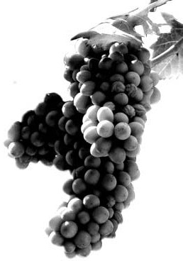This sample label is applicable to the production of wines by wineries exercising an exemption from certification found at 7 CFR part 205.101(a)(3) or 7 CFR part 205.101 (a)(4). Products exempt from certification may contain less than 70 percent organically produced ingredients, not counting added water and salt. In addition, the product may contain over 30 percent non-organically produced agricultural ingredients and/or other substances without being limited to those in 7 CFR 205.605. The term “organic” shall only appear in an ingredient statement and the accompanying percentage statement. You should also consider the following points in designing your label:
Grapeful
CALIFORNIA RED WINE
13.2% Alc./Vol.

750 ml
PDP - (PRINCIPAL DISPLAY PANEL) That part of
the label that is most likely to be displayed, presented, shown, or examined under customary conditions of display for sale.

IP - (INFORMATION PANEL) That part of the label of a packaged product that is immediately contiguous to and to the right of the principal display panel as observed by an individual facing the principal display panel, unless another section of the label is designated as the information panel because of package size or other attributes (e.g., irregular shape with one usable surface).

OP - (OTHER PANEL) Any panel other than the principal display panel, information panel, or ingredient statement.

IS - (INGREDIENT STATEMENT) The list of
ingredients contained in a product shown in their common and usual names in the descending order of predominance.
KEY

INGREDIENT STATEMENT
Products restricted to an “Organic Ingredients” statement may show a complete ingredient statement. The term “organic” may only be used in an organic ingredient statement to identify the specific ingredients and in the accompanying percentage statement. Water and salt included as ingredients may not be identified as “organic.” The ingredient statement may only appear on an IP.

PERCENTAGE STATEMENT
(Organic and Non-Organic Ingredients)
The phrase “X% Organic” or “X% Organic ingredients” must be included on the labeling. The percentage statement may only appear on an IP.

PERCENTAGE STATEMENT
(No Non-Organic Ingredients)
If a wine bears an “Organic Ingredients” Statement in which no disclosure of non-organic ingredients is made, such as “Ingredients: Organic Grapes,” then 100% of the ingredients in such wine must be organic.

When 100% of the ingredients are organic on a wine restricted to an “Organic Ingredients” statement, a Percentage Statement is prohibited.

DEPARTMENT OF AGRICULTURE AGRICULTURAL MARKETING SERVICE WASHINGTON, DC 20250

DEPARTMENT OF THE TREASURY ALCOHOL AND TOBACCO TAX AND TRADE BUREAU
WASHINGTON, DC 20220

THE LABELS MUST NOT SHOW:

THE USDA ORGANIC SEAL THE CERTIFYING AGENT SEAL A CERTIFICATION STATEMENT
THE TERM “ORGANIC” IN THE ABSENCE OF AN INGREDIENT STATEMENT

TTB P 5190.11 for Organic Wine Labeling
Grapeful
Ingredients: Organic Cabernet Sauvignon Grapes, Merlot Grapes, Tartaric Acid, CONTAINS SULFITES
55% Organic Ingredients PRODUCED & BOTTLED BY:
GRAPEFUL CELLARS, SOLIS, CA
GOVERNMENT WARNING: (1) ACCORDING TO THE SURGEON GENERAL, WOMEN SHOULD NOT DRINK ALCOHOLIC BEVERAGES DURING PREGNANCY BECAUSE OF THE RISK OF BIRTH DEFECTS. (2) CONSUMPTION OF ALCOHOLIC BEVERAGES IMPAIRS YOUR ABILITY TO DRIVE A CAR OR OPERATE MACHINERY, AND MAY CAUSE HEALTH PROBLEMS.

