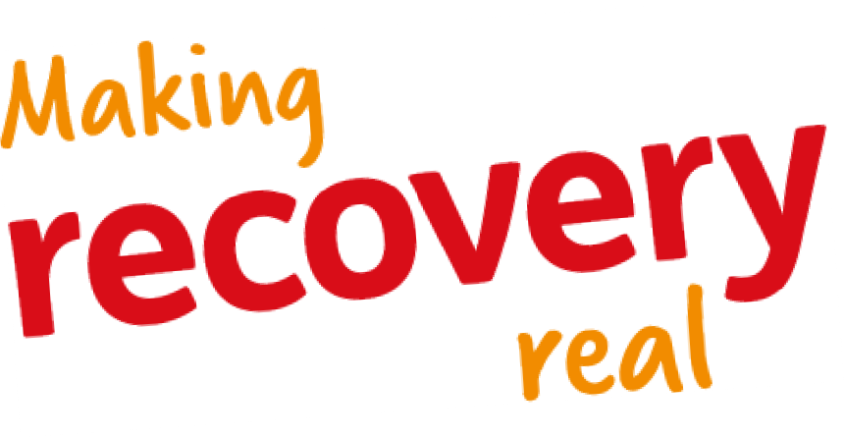

Launch event planning: Proposal

Introduction
This proposal was drawn up by Ruth Brown, Tom Garnett, Rose Sinclair, Gillian Tracey, Emma Wilson and Louise Christie at a meeting to discuss the planned Making Recovery Real launch event. This paper sets out what was agreed with regard to:

  - The purpose of the event
  - The target audience
  - Publicising the event
  - The structure and content of the event
  - The venue
  - The actions required to deliver the event successfully.

The Discovery Point venue has been booked for Wednesday 25th November 2015.

Purpose of event

It was agreed that the purpose of the event was to:

  - To introduce the Making Recovery Real project to a wider audience;

  - To raise awareness and understanding of recovery and the difference it makes to people’s lives by showcasing lived experience and recovery stories;

  - Provide opportunities for people to feed their lived experience and views into the process.

The event should feel open, friendly and informal and provide a range of opportunities for people to feed in their lived experience and views and hear about

others. The structure of the day will provide for a good balance of speakers; group discussions; creative activities; networking and feedback.

Who do we want to attend?

The two main target audiences for the event are:

  - People with lived experience of mental health problems and recovery;

  - Local influencers and decision makers.

These are two very different groups and the publicity for the event will need to be tailored to ensure that both groups see the event as something they want and need to attend. The various partners will be able to help in identifying key people and contacting them to encourage attendance.

The event will also be open to local practitioners and carers and families of people with lived experience of mental health problems.

Ruth is drafting a detailed event invitation list which will be circulated for input by partners.

Publicising the event

In advance of the event publicity will be focused on ensuring we attract the target audiences for the event. This will be done by:

  - Tailored publicity – email invites, letters, telephone contact;

  - Generating interest through articles in local newsletters;

  - Securing a high profile keynote speaker to introduce the event such as Shona Robison, Cabinet Secretary for Health, Wellbeing and Sport and MSP for Dundee West;

  - Securing one or more high profile local figures to promote the event and/or be there on the day. Options include Lorraine Kelly and Ricky Ross.

We will also contact the local press and media to secure coverage of the event. Publicity after the event will have a local as well as wider focus through partner’s networks and will be based on feedback from those attending and the use of photographs and video to capture people’s thought and views and also the experience of the event. This can be done through the use of social reporters on the day who can gather views from people using video and sound.

Structure of the day

The event will run from 11am to 3pm and comprise of three main sections:

  - An introductory session of 1 hour featuring keynote speakers; a video showcasing lived experience and short table discussions;

  - An extended lunch session of 90 minutes where, in addition to lunch and networking, there will be an opportunity to take part in a range of activities provided by local groups and organisations;

  - A final session of 75 minutes which will use a World café format to gather views and feedback from the participants on a couple of key questions.

This will leave around 15 minutes for a short final session which will focus around a call to action and encourage people to stay involved with the project.

The following table provides more detail on the proposed content of the event.

10.30 | Registration and tea/coffee | Upper reception Falcon Scott Suite
11.00  11.05  11.20  11.25  11.35  11.50  11.55 | Welcome to the event Speakers:  - Shona Robison  - David Lynch Lived experience video  Quick table discussion:  - Who am I?  - What does recovery mean to me?  Why we are involved in Making Recovery Real? Speakers:  - Avril Smith Hope  - Val Johnson | Falcon Scott Suite or Falcon Scott and Terra Nova combined
12.00 | Recovery activities and lunch  - Possible activities and groups being sought | Education Suite Upper Reception
13.30 | Recovery Café  - Hosted table discussions focused around two key questions (to be agreed) | Falcon Scott Suite Terra Nova Education Suite
14.30 | Getting started on ‘Making Recovery Real’ Call to action with music | Falcon Scott Suite

Issues for consideration:

  - The timing in the first session is very tight and we may decide to have fewer speakers. If we have messages from high profile local people in person or by video time will have to be found in this first hour for them. Extending this session would mean losing other parts of the day that are more participative and fun.

Emma and Gillian will work to plan and produce a short lived experience video

Venue

We have booked Discovery Point Falcon Scott Suite, Terra Nova, Education Suite) which provides us with:

  - A main room which takes either 60 or 80 cabaret style (Falcon Scott and Terra Nova can be combined to make a larger space)

  - One or two second rooms of 40m² (Terra Nova) and 80m² (Education Suite – has mezzanine level)

  - Use of the Upper Reception Area for coffee/tea and lunches if required

The cost of hiring the three rooms would be around £650 and there is the possibility of a small discount if we book all three. The total cost of room hire and catering for 60 to 80 people is likely to be around £2,000 including VAT.

