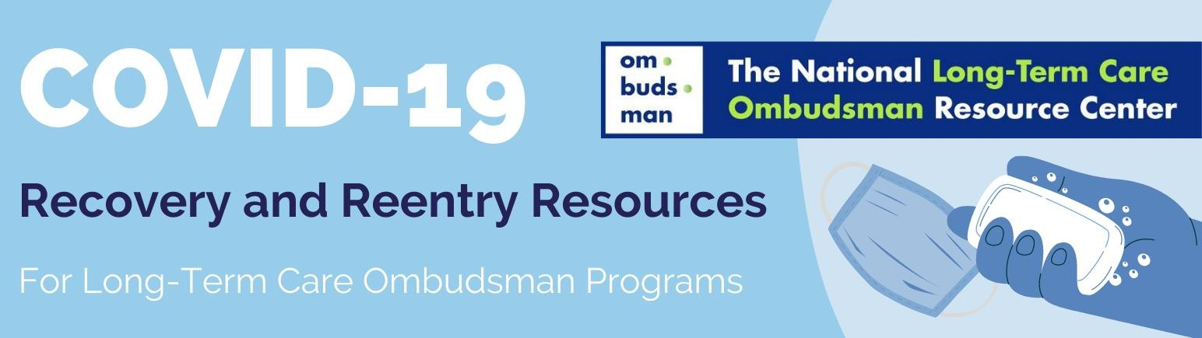

COVID-19 Self-Assessment Form Template
Attention State Ombudsmen
- This template is designed for representatives and the state Ombudsman to complete and submit prior to every visit to a long-term care facility. The questions in the form are based on common screening questions provided by the Centers for Disease Control and Prevention (CDC), such as this CDC Facilities COVID-19 Screening document.
- Determine if the COVID-19 Symptom Self-Assessment form is voluntary or required prior to a
representative’s visit to a facility. Share specific guidance with all program representatives.
- Adapt the form to meet the needs of your state program. You may want to have your human resources review and as applicable, coordinate with host agencies of local Ombudsman entities.
- Determine if the completed form is to be shared with a supervisor. Consider the following:
  - Will the supervisor receive the form in-person prior to the representative’s planned visit to a
facility?
  - Will the supervisor receive an electronic copy of the completed self-assessment form?
  - Confidentiality and records storage protocols for completed self-assessment forms shared with supervisor.
  - Protocols for supervisors to follow regarding that person’s availability to visit facilities.
- This self-assessment form assumes that the Office of the Long-Term Care State Ombudsman (Ombudsman) has made infection control training available to representatives and that the representatives have demonstrated that they understand the correct way to use face coverings and other protective equipment.
August 2020
This project was supported, in part, by grant number 90OMRC0001-01-00, from the U.S. Administration for Community Living, Department of Health and Human Services, Washington, D.C. 20201. Grantees undertaking projects under government sponsorship are encouraged to express freely their findings and conclusions. Points of view or opinions do not, therefore, necessarily represent official Administration for Community Living policy.

COVID-19 Self-Assessment Form
Name: Date:
Temperature:

In the last 30 days, have you: | Please Circle: |  | Comments:
Tested positive for COVID-19? | YES | NO
Been exposed to someone who tested  positive for COVID-19? | YES | NO
Traveled outside your county of residence, state, or the U.S.? | YES | NO | If YES, where?
In the last 2 – 14 days, have you had: | Please Circle: |  | Comments:
Fever or chills | YES | NO
Cough | YES | NO
Shortness of breath | YES | NO
Difficulty breathing | YES | NO
Fatigue | YES | NO
Muscle or body aches | YES | NO
Headaches | YES | NO
New loss of taste or smell | YES | NO
Sore throat | YES | NO
Congestion or runny nose | YES | NO
Nausea or other digestive symptoms | YES | NO

I affirm and certify that the information and answers to questions herein are complete, true, and correct to the best of my knowledge. I understand that this information may be shared with public health officials in their official capacity of tracking COVID-19 outbreaks of significance.
Signature:

Supervisor Signature: | Facility/Facilities Visiting Today:

