[](http://www.hloom.com/)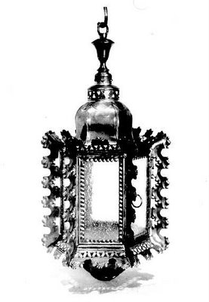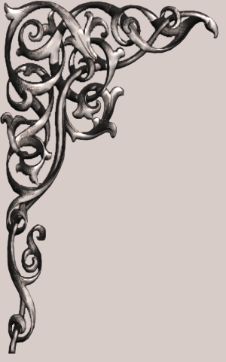

PLEASE JOIN US TO CELEBRATE

THE SEASON WITH A FESTIVE

Holiday Party

SATURDAY, SEPTEMBER 28, 2013

7:00PM

JOANIE & BLAKE SMITH

4221, BROADMOOR LANE

BATON RAUGE

RSVP (515) 123 4567