Postcard from Space

“Hi! I’m Nick PaTrick. AfTer a greaT career as an asTronauT aT NASA, I came To Blue Origin, where I now serve as our Human InTegraTion ArchiTecT, developing sysTems To help us reach The day
when There are millions of people living and working in space To benefiT EarTh. Engineers and scienTisTs aT Blue Origin are focusing Their efforTs on Three main Technologies you see below.”

NEW SHEPARD NEW GLENN

Named after Alan Shepard, the first American to go to space, this is Blue Origin’s fully reusable suborbital rocket system designed to take astronauts and research payloads past the Kármán line – the internationally recognized boundary of space, and back to Earth.

BLUE MOON
Named after pioneering astronaut John Glenn, New Glenn is Blue Origin’s heavy lift launch vehicle designed for carrying people and payloads routinely to Earth orbit and beyond. New Glenn will build a road to space!

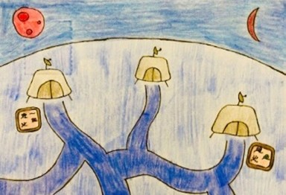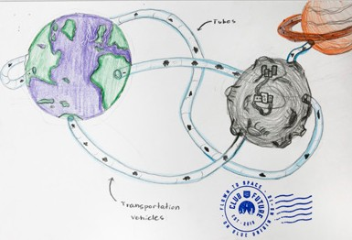Blue Origin’s lunar lander that will deliver large payloads to the lunar surface and even deploy payloads during its journey to the Moon. Its technology builds on New Shepard’s with rocket engines, precision guidance, and vertical landing.

W H AT W OULD Y OU LIKE T O INV ENT ?
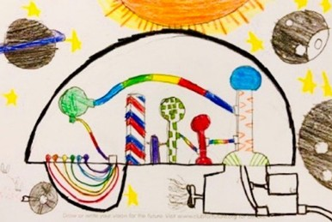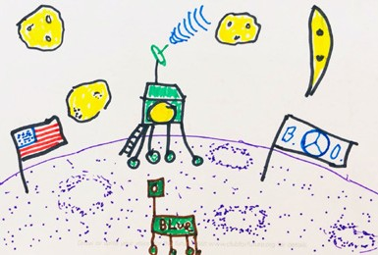YOUR MISSION: Sketch a prototype for new technology that could be used to help meet the needs of millions of people living and working in space. Cut out the postcard below and when you finalize your big idea, write or draw it on the back of the post- card. Put your address on the front, place it in an envelope and mail it to: Club for the Future PO Box 5759 Kent, WA 98064 and Blue Origin will send it into space on the New Shepard rocket. When it returns to Earth, it will get our verified, ‘Flown to Space’ stamp, then get shipped back to you for free!

TEACHER LESSON PLAN - POSTCARD FROM SPACE
ENGINEERING FOR SPACE

INTRODUCTION
Opportunities for innovation related to the space economy are increasing rapidly. A wide variety of new and exciting technologies are being developed related to space travel and exploration. It is an exciting reality that your students will have the chance to bring their own engineering ideas related to space to the forefront. In this lesson, students will take on the role of an engineer designing new technology that will help people living and working in space.

LEARNING OBJECTIVE
Sketch a prototype design for new technology that could be used to help meet the needs of people living and working in space.

STANDARDS

NGSS
MS-ETS1-1. - Define the criteria and constraints of a design problem with sufficient precision to ensure a successful solution, taking into account relevant scientific principles and potential impacts on people and the natural environment that may limit possible solutions.

CCSS.ELA-Literacy.SL.6.5
Presentation of Knowledge and Ideas:
Include multimedia components (e.g., graphics, images, music, sound) and visual displays in presentations to clarify information.

ISTE
4d - Students exhibit a tolerance for ambiguity, perseverance and the capacity to work with open-ended problems.

INSTRUCTIONS
- Brainstorm ideas for a prototype invention that will help people living and working in space.
- Choose the best idea and create a design sketch for your prototype.
- Use your design sketch to present your idea.
- Draw your favorite idea on your postcard.
- Send postcard to the Club for the Future where it will be sent into space on a New Shepard rocket.
- Tune in to watch the launch event and sign up for the Club to receive updates.

LESSON EXTENSION
- Research current technology that is being used to help accomplish the goal of humans living and working in space.
- Research different types of space engineering jobs.

REFLECTION
- Ask students to share their ideas for a prototype invention that will help people living and working in space.
- Ask students to partner up with other students that have design ideas that related to their own. Have them discuss and share how they could work together.

POSTCARD INSTRUCTIONS

SEND A POSTCARD TO SPACE
The Club for the Future is asking students from around the world to send them postcards answering the question:

WHAT WOULD YOU BUILD IN SPACE, THAT COULD HELP THE EARTH?

Once you have your idea, draw it on a postcard, then mail it to the Club. Then, the Club will put your postcard on one of Blue Origin’s New Shepard rockets and launch it to space!

Upon your postcard’s return from space, it will be stamped “Flown to Space” then mailed back to you as a special keepsake.

We have already launched thousands of student’s ideas to space – now let’s send yours!If you have more than one postcard, are a classroom, a school, or organization, you may package multiple postcard in to one large envelope or box to simplify shipping. Club for the Future will happily re-package postcards and return them to sender
for distribution.
.

ADDRESSING YOUR POSTCARD TO SPACE (AND BACK)

GRAB A BLANK 4”X6” (10cmX15cm) POSTCARD

DRAW OR WRITE YOUR VISION OF WHAT YOU WOULD BUILD IN SPACE THAT COULD HELP EARTH

FILL OUT YOUR HOME ADDRESS AND ADD A STAMP ON THE BACK SIDE (SO WE CAN SEND IT BACK TO YOU)

CLUB FOR THE FUTURE PO BOX 5759
KENT, WA 98064 U.S.A.

PLACE THE POSTCARD IN A STAMPED ENVELOPE ADDRESSED TO CLUB FOR THE FUTURE

PUT THE ENVELOPE IN A MAILBOX. WE’LL SEND IT TO SPACE AND THEN BACK HOME TO YOU!

SHARE YOUR SPACE MAIL WITH THE WORLD! TAKE A PHOTO AND POST IT ON TWITTER, FACEBOOK, OR INSTAGRAM. #CLUBFORTHEFUTURE

AND DON’T FORGET TO OFFICIALLY JOIN THE CLUB TO BE ON THE LOOKOUT FOR THE NEXT ACTIVITY!

W W W . C L U B F O R F U T U R E . O R G

FOUNDED BY

