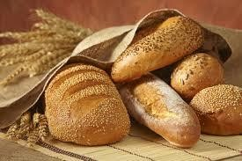

Industry Analysis
Bakery Industry
By: Annie Doolittle, Ashlee Jones, Lisa Pope, Oksana Vorontsov, Jeffrey Wray
12/12/2013

Table of Contents

Introduction 3
Background 3
Dominant Economic Characteristics… 4
Key Success Factors 11
Six Forces of Competition 13
Competitive Position of Major Companies 18
Industry Prospects and overall Attractiveness 31
Conclusion 33
References… 34

Introduction

The baking industry in the United States is those companies that focus on and manufacture baked goods. Mainly these baked goods consist of some type of bread but it can also included items such as cakes, cookies, crackers and pastries just to name a few. Baking is
the act of making food such as cakes and breads “by preparing a dough, batter, etc., and cooking it in an oven using dry heat” (Merriam-Webster Dictionary.) Other foods may be baked like meats, vegetables and some pasta dishes, but for the purposes of this analysis we will be focusing on the “baked goods” that include breads, cakes etc.

Background

Baking goes as far back as at least 2600 B.C. It is the Egyptians that are credited with using the baking technique first. They are also credited with the first use of leavening, or the use of yeast to make the dough rise, in bread. It was the Egyptians that also came up with the first ovens to bake these breads in. From Egypt, baking spread to ancient Greece and then into the Roman Empire where it flourished around the 3rd century B.C. and pastries became all the rage. Anyone that could produce a good pastry was highly sought after and by 1 A.D. there were over three hundred pastry chefs in Rome alone. With the widespread reach of the Roman Empire the technique of baking did not take too long to spread to other parts of the world. From Europe to Asia people started baking and it started to become a more common element of a person’s daily life. Through most of Europe, street merchants popped up selling their freshly baked goods to passerbies. Some of the goods sold were cakes, gingerbread, and pancakes.
With the development of machines and the industrial revolution, baking developed into an industry and really grew here in the United States as factories were built and the means of transporting the baked goods, such as the railroads, were established. The invention of the

modern day oven and ingredients such as preservatives and other food additives also played a big role in the spread of the popularity of baked goods. In the U.S. today the baking industry accounts for over 600,000 jobs and over $102 billion a year. It is especially big here in the state of California with over 89,000 jobs that are directly related to the baking industry with over 4.6 million paid in wages to those workers. In 1897 the American Bakers Association was founded
to be the “voice” of the baking industry and to help grow and enhance the baking industry. Today the American Bakers Association has grown to become one of the top trade associations, if not number one, for the baking industry. Today there are many companies in the baking industry but really there are only a few major players on the baking industry stage. Those will be discussed here in this report.

Dominant Economic Characteristics

Market Size

The baking industry plays an important role in the US economy, generating over 30 billion dollars of revenue in 2013. There are 2,800 commercial bakeries and 6,000 retail bakeries in the United States. This illustrates the scope and size of the industry. While there are many bakeries in the US, the top four producers account for 35% of the industry revenue and commercial producers account for 91% of the total revenue in the industry. The industry is fragmented due to the majority of firms in the industry being small retail bakeries located throughout the Unites States.

Scope of Competitive Rivalry

The baking industry is highly competitive because most bakeries are small to medium size producers that serve a highly fragmented market. Competition among the key players in the

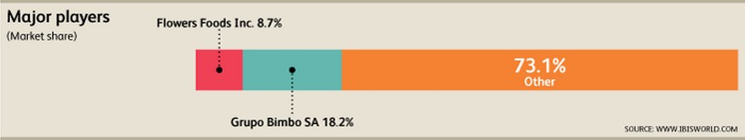
industry is based on price, quality, differentiation, and nutritional value. Two major players in the baking industry in the United States are Flowers Foods Inc. and Grupo Bimbo.

Combined these two power companies make up 26.9% of the baking industry. A few of the smaller players in the industry include Hostess Brands LLC, Krispy Kreme Doughnuts Inc., and Campbell Soup Co. The most important determinant of competition in the industry is price. Consumers have high purchasing power, and the majority of small producers cannot compete with the lowest prices. Innovation and differentiating products is important to remain a strong competitor.
The baking industry is homogeneous and product differentiation is necessary to separate from competitors. Marketing initiatives must be a priority to increase demand, as brand recognition is another key competition factor. In addition, consumers are likely to pay more for a well-known brand.

Market Growth

The industry has experienced slow growth in the last five years due to changes in consumer preferences and the economic downturn. Although annual growth decreased .3% from 2008 to 2013, it is expected to increase by .7% from 2013 to 2018. This is because sales and revenue reflect the conditions of the economy, and disposable incomes have been rising. Big companies have grown exponentially in the last five years. This is due to acquisitions and mergers. Grupo Bimbo acquired Sara Lee and Weston Bread Unit, making it the largest baked

goods company in the US. Although the current market concentration is low, it is beginning to rise as the number of mergers and acquisitions increase. Currently, the baking industry is at maturity in the industry lifecycle. This means that bread and other baked goods are widely accepted by US households. As economic conditions and consumer preferences change, the baked goods industry shows slow growth.

Customers

99% of US households consume baked goods leading to a giant and diversified consumer base. Over the past five years, per capita disposable income has decreased and the US economy has limited growth in the baking industry. Consumers were mostly purchasing baked goods from supermarkets and wholesale outlets as opposed to consuming baked goods from restaurants.
However this trend is predicted to change over the next five years, and in 2014 revenue is anticipated to grow 1.9%. As the recession is coming to an end American citizens are spending more time at work. Technomic’s 2012 Snacking Consumer Trends Report explains that consumers are snacking more as they become busier over time. This will ultimately lead to a decrease in the purchasing of bread products because consumes will rely on substitute products such as nuts, yogurt, fruit and cereal bars.
Companies in this industry have the challenge of keeping up with America’s constant changing consumer health trends. Consumers are becoming more health conscious and nutrition preferences are changing including gluten free, low-carbohydrate and Paleo diets. The pressures from consumers have led companies to increase product differentiation such as low-calorie, low- carbohydrate, and whole grain products. Paleo, an all-natural raw food diet eliminated bread completely. Although these nutritious trends affect the baking industry, their impact is small and

unlikely to change in the industry significantly. Companies will continue to introduce new products that satisfy the consumers’ nutritious preferences.

Degree of Vertical Integration

Firms in the baking industry use forward vertical integration. Because producers seek other suppliers for flour, dairy products, sugar and many other ingredients to create its products, backward integration is not used. Retail bakeries manufacture and wholesale their products.
While commercial bakeries usually have extensive distribution networks, they do not directly sell to the final consumers. Instead they distribute their products to supermarkets, restaurants, specialty food stores, and convenience stores, just to name a few. In fact, the largest downstream market for this industry’s market is supermarkets, grocery stores and wholesale clubs, accounting for 59.1% of revenue in 2013. Access to these downstream markets is crucial for the success of the large firms in this industry.
Vertical integration has many benefits and drawbacks for the baking industry. Using vertical integration improves the coordination of the supply chain for both small and large firms. Small firms are able to manufacture and wholesale their products while large firms have invested in extensive distribution networks with retail outlets. In addition, large firms are able to gain access to downstream markets that greatly increase their sales. Also, supply and demand is synchronized with vertical integration. A downside of using forward vertical integration is the cost. Developing, establishing, and maintaining a successful distribution network requires time as well as increased monetary capital.

Ease of Entry/Exit

The ease of entry into the baking industry is high and the barriers to entry in the baking industry are low including initial capital investment, competition with key players, and

relationships with major retailers. Initial capital investments can be extremely high depending on the necessary scale of production, therefore deterring new entrants. The largest barrier that new entrants face is having to compete with the key players, such as Flower Foods Inc. and Grupo Bimbo, who have already developed their reputation, customer loyalty and brand recognition.
Success from new entrants often comes from low products and concentrated geographic areas. Another major barrier to entry is obtaining relations with major supermarkets that have already given shelf space to developed brands. Unfortunately costs are high as small entrants introduce their products with small independent markets and local bakeries. Due to the market concentration being low and extremely fragmented, the ease of exit in this industry is high.

Technology and Innovation

Technology and innovation have drastically changed the baking industry. New production techniques, e-commerce, and product development have shaped the current operations of firms in the industry. Small-scale production units have been created to perform the same function as large-scale units. This makes retail bakers more competitive with commercial bakeries because they can efficiently produce specialized bread products using an automated system. Although this reduces labor costs for small firms, it also has lead to decreased employment.
In addition, e-commerce and manufacturing technology is a major development in the baking industry. Computerization of process increases efficiency and accuracy. For example, with the introduction of conveyors, collators, and automated packers, the packaging process has greatly improved. Also, new systems are used to track inventory, production, and shipments.
These implementations strengthen the relationship between customer and supplier. They also help producers accurately gauge the demand of the market. Product innovation has become

increasingly important in the industry. Producers must create new products that appeal to the changing consumer preferences. Also, big companies such as Grupo Bimbo hire scientists and specialists to research product and market development. These new technologies, systems, and innovations have contributed to the baking industry environment.

Product Characteristics

Product segments in the baking industry include: bread, desserts, rolls, and doughnuts.

Product innovation has been a key element of this industry as consumer preferences have changed in the last five years. Consumers are more knowledgeable and concerned about health and nutrition. Because of this, manufactures have created new healthier baked goods options to appeal to consumers. In 2010, wheat bread sales surpassed white bread sales for the first time. Organic, gluten-free, whole grains, and low calorie are some of the many nutritional trends.
Producers in the industry invest in more expensive ingredients to create products lower in fat and calories. This has also led to an increase in product lines offered. Bakeries have started offering gluten-free and all-organic dessert options. Because rolls are considered a staple item, simply offering reduced fat varieties helped maintain its revenue. Smaller portions and eliminating trans fats from doughnuts have stabilized revenue in the doughnut segment. Overall products in this industry can be characterized by a shift to healthier and nutritional offerings.

Scale Economies

Economies of scale occur when more units of output can be produced for smaller input costs. It is difficult for small firms in the baking industry to reach economies of scale due to the volatile nature of input prices. When input costs jumped 27.7% in 2008 large companies were able to compensate by lowering other production costs. This allowed the large firms to keep prices low, stabilizing demand. Small firms were unable to compete with these prices because

their per-unit cost increased as input costs increased. Initial investments must be made for firms in the baking industry to achieve economies of scale. New machinery and technology is an expensive investment that ultimately leads to the decrease in cost per-unit of output. This is largely due to the decrease in labor hours as well as faster and more efficient production.
Ultimately it is the large firms in the industry who achieve economies of scale due to their large scale of production.

Experience Curve Effects

The longer a company competes in a particular industry, the more efficient they become leading to decreased costs. This has a huge impact on the baking industry because of the magnitude of operation of the few leading firms. As costs decrease, companies with the largest market share experience the greatest cost advantage over the smaller producers. This creates an even bigger gap between the firms in the baking industry. The effects of this curve result from and increase in efficiency of operations and lead to increased productivity. Costs decrease as firms develop experience overtime in the industry.

Capacity Utilization

Capacity utilization is the relationship between output that is being produced and the potential output that could be produced. As demand grows, capacity utilization increases and vice versa. Insufficient demand is an indicator of excess capacity. The capacity utilization in the baking industry directly correlates with US economy. Staple foods such as bread will always be in high demand, but non-staple items such as pastries and desserts are purchased as a luxury. The recession caused a decrease in disposable income, forcing consumers to cut back on unnecessary purchases. This decrease in demand of baked goods caused the capacity utilization to

dramatically decrease. As demand for baked goods increases the capacity utilization will also increase.

Industry Profitability

Although revenue in the industry is high, profits are low due to increasing prices of inputs. Because wheat and sugar are two of the primary ingredients in many of the industry’s products, as wheat and sugar prices increase the industry’s profit margins decrease. These input costs are growing faster than revenue. Profits will also decline as a result of the many mergers and acquisitions. This is because there are many costs that are incurred from merging different operations. The recession also contributed to decreased profitability in the baking industry as disposable incomes plummeted. The baking industry continues to experience increasing revenues, but the profitability remains low.

Key Success Factors

Within any industry there are usually certain key success factors that a company’s management team must understand in order to be successful. Key success factors are variables that can significantly affect the overall competitive positions of companies within any particular industry. The key success factors vary from industry to industry and are usually determined by the economic and technological characteristics of the industry. In the bakery industry there are a few key success factors that were identified and they are as follows:
Ability to pass on cost increases: Successful firms are able to pass on high input costs such as wheat and sugar to the final consumer to maintain profitability.
Supply contracts in place for key inputs: Reliable contracts with suppliers of key raw materials such as wheat and sugar considerably reduce supply volatility. Guaranteed supplies at fixed prices minimize supply costs and aid production planning.

Proximity to key markets: Successful firms have production facilities located near consumers because of the perishable nature of bread and the high cost of transporting these goods.
Use of most efficient work practices: Due to the moderate labor intensity and corresponding high ratio of wages to revenue, workplace efficiency is a main factor determining production speed and volumes.
Product differentiation: Successful firms are able to differentiate their products from their competitors’ products to maintain market share and increase sales revenue.
Establishment of brand names: Brand recognition and popularity is critical for firms that want to expand into new channels (e.g. convenience, coffee shops) and obtain greater shelf-space in supermarkets and grocery stores.

Industry Matrix

Key Success Factors | Weight | Grupo Bimbo SA Rating | Grupo Bimbo SA Weighted Score | Flowers Foods Rating | Flowers Foods Weighted Score
Ability to pass on  cost increases | .31 | 4.1 | 1.271 | 3.9 | 1.209
Supply contracts in place for key  inputs | .20 | 3.8 | .76 | 3.6 | .72
Proximity to key  markets | .11 | 4.5 | .495 | 4.5 | .495
Use of most efficient work practices | .16 | 3.5 | .56 | 3.4 | .544
Product  differentiation | .12 | 3.2 | .384 | 4.9 | .588
Establishment of  brand names | .10 | 5 | .5 | 3.8 | .38
TOTAL | 1.00 |  | 3.97 |  | 3.936

The results show that Grupo Bimbo SA is leading in the total weight which matches Grupos financial totals. Grupo Bimbo SA is the leader in the industry and has established recognizable brands, while Flowers Foods Inc. has a wide product portfolio. Each of these companies can learn something from each other.

Six Forces of Competition

Michel Porters five (sixth added) forces of competition determine the potential profit potential in the industry. All six forces; threat of new entrants, rivalry among existing firms, threat of substitute products or services, bargaining power of buyers, bargaining power of suppliers, and relative power of other stakeholders will be discussed later for the baking industry. The stronger each of these forces are the more limited companies are in their ability to raise prices and earn greater profit.

Threats of New Entrants

According to Wheelen and Hunger in our textbook, new entrants to an industry bring to it new capacity, a desire to gain market share, and substantial resources. Many established corporation feel that this is a threat to them. The threat depends on the barriers to entry in each industry. For example, in the baking industry the threat to new entrants is relatively low because the amount of resources that are required to start a business and the development of a distribution network. Some of the possible barriers to entry are: economies of scale, product differentiation, capital requirements, switching costs, access to distribution channels, cost disadvantages independent of size, and government policy.
The barriers to entry in the baking industry are low, although the initial capital investment required can be high depending on the scale of production. New entrants need the facility and

equipment to begin bread production. Those that are unable to secure financing to make these investments will not be able to participate in the industry.

Rivalry among existing firms

The baking industry is characterized by a low level of concentration, with the top four players estimated to account for 35.0% of industry revenue in 2013, up from an estimated 20.3% of industry revenue in 2008. The increase came about due to growth for major players and an increase in merger and acquisition activity. For example, Grupo Bimbo acquired Weston Bread Unit in 2008 and Sara Lee's North American Fresh Bakery segment in 2011, both of which greatly increased the company's market share. Due to rapid growth through acquisitions, Grupo Bimbo is now the largest player in the industry.
Most of the companies in the industry are smaller and are dispersed across the country, making the Bread Production industry somewhat fragmented. In fact, firms employing fewer than five workers make up nearly half of all enterprises and four out of five firms employ 20 people or less. Many companies are local and only serve a small portion of the population. Some regional brands have a greater geographical reach but cater to consumers with specific health and diet needs (e.g. celiac disease, nut allergies). As larger firms merge with and acquire these smaller players over the next five years, rivalry is expected to increase.

Threats of substitute products or services

A substitute product is a product that appears to be different but can satisfy the same need as another product. According to Porter, “Substitutes limit the potential returns of and industry by placing a ceiling on the prices firms in the industry can profitably charge.”
Baking products fall into the category of staple foods. Therefore, appropriate substitutes for bread as the most essential baking product are difficult to find. Perhaps products such as

breakfast cereals, oatmeal porridge, crackers, rice, pasta and similar products that are not generally eaten with bread could be regarded as potential bread substitutes. However, the danger of introducing substitute products is rather small.

Bargaining power of buyers

Today's savvy consumer is educated when it comes to their food choices and how to actively choose food products including baked goods. This gives the consumer power over retailers to match their need for products and preferences. Customers know what they want and at what price they want it. It is that simple. Today's consumer is constantly bombarded with options due to different types of media. Retail design as a concept for enticing new consumers is a constant in the market. This aids in driving the competition to find an advantage. The consumer knows it has a wide range of choices. They understand food products better and use this to shop around for the best product. As a result, the ability for a retailer to switch cost is very low.
Everything depends on the quality of product.

Bargaining power of suppliers

Suppliers can affect an industry through their ability to raise prices or reduce the quality of purchased goods and services. A supplier or supplier group is powerful is some of the following factors apply: the supplier industry is dominated by a few companies, its product or service is unique and/or has built up switching costs, substitutes are not relatively available, suppliers are able to integrate forward and compete directly with their present customers, and a purchasing industry buys only a small portion of the supplier group’s goods and services and it thus unimportant to the supplier.
The bargaining power of the suppliers in the baked goods industry is relatively low because of the nature of the product. The supplier is legally bound by government guidelines to

uphold FDA standards. Still this puts them in a role of great influence. Companies like Grupo Bimbo SA and Flowers Foods Inc. have had to adopt an aggressive attitude with suppliers so they can provide diverse products to the consumer. The supplier has no room to bargain either due to increased competition on the wholesale market. One's health is a serious matter, which is why it makes it easier for the company to switch suppliers to meet the needs of the customer.
They are also educated and looking for a company that can go the extra mile to please them. In this industry, companies are constantly bargaining for the best price and suppliers are willing to yield to meet this demand for fear of losing a client.

Stakeholders

The sixth force that is added to this analysis is the relative power of other stakeholders.

The two big stakeholders in the bakery industry is the Food and Drug Administration (FDA) and the Environmental Protection Agency (EPA).
Environmental Protection Agency (FDA)

The Food and Drug Administration's mission is to promote and protect the public health by ensuring that safe and effective products reach the market in a timely way. They also monitor products for continued safety. The Nutrition Labeling and Education Act, which amended the FD&C Act, requires that most foods, including bread, feature nutrition labeling on their packaging. Also, the Act requires that labeled foods include nutrient content claims and certain health messages to comply with specific requirements. Furthermore, the FDA instituted the Food Ingredient Safety Program that governs and evaluates claims about ingredients, nutritional content and other claims made by food producers.
The United States and its consumers are demanding more stringent rules related to food labeling, advertising and packaging. Failure to abide by them can damage a producer's

credibility, resulting in expensive product recalls and making the company liable to civil or criminal penalties. Pending enforcement of new FDA regulations has created new opportunities for food manufacturers to differentiate themselves from the competition. Companies that actively comply with regulations and safety requirements can benefit from efficiency, quality and brand integrity.
Environmental Protection Agency (EPA)

The Environmental Protection Agency (EPA) and different state governments enforce environmental regulations pertaining to the food processing industry. Various federal environmental regulations and statutes, such as the Clean Water Act (CWA), Clean Air Act, Pollution Prevention Act and Resource Conservation and Recovery Act, have changed the way processing facilities handle their products and dispose waste. The CWA's increasingly rigorous regulations for discharging wastewater are the primary regulatory drivers for the food processing industry. Also, firms must acquire a National Pollutant Discharge Elimination System permit to discharge wastewater into treatment facilities.
The federal pollution prevention principles and the subsequent development of clean technologies have been viewed as ways to provide cost savings and improve product quality. Furthermore, adherence to these regulations can improve public sentiment toward companies or industries that aggressively pursue implementation. Pollution prevention is also an effective means of reducing compliance and treatment costs for food manufacturers. Unlike other food processing industries, pollution is not a major problem for bread production as large quantities of waste are not emitted.

Competitive Position of Major U.S. Baking Companies

Currently, there are three major corporations involved in the U.S. Baking Industry.

Those companies are Grupo Bimbo, S.A.B. de C.V. which operates as Bimbo Bakeries USA (“BBU”), Flowers Foods, Inc. (“Flowers”), and Campbell Soup Company (“Campbell’s). There are also many smaller, regional baking companies throughout the U.S. It should be noted that until recently there was also a fourth corporation in the U.S. Baking Industry, Interstate Bakeries Corporation/Hostess Brands, Inc. (“Hostess”). This company was in and out of bankruptcy for several years. In November of 2012, Hostess employees, who were part of the Bakery, Confectionery, Tobacco Workers and Grain Millers’ Union, went on strike over contract proposals that would cut employee salaries and benefits. On November 16, 2012, Hostess announced that it was ceasing plant operations. On November 29, 2012, a federal bankruptcy judge finalized the liquidation plan of Hostess Brands, Inc. Several of Hostess Brands bread brand items have been sold to large and small companies throughout the U.S. Among the purchasers of those items were BBU and Flowers, representing the larger U.S. bakeries, and United States Bakery, Inc., a/k/a Franz Family Bakeries, which is a small, regional bakery located in Portland, Oregon.
Among the three largest remaining corporations in the U.S. Baking Industry, BBU is the largest of the U.S. bakeries with 2012 sales of $13.2B and 2012 net income of $155M. Flowers is second with 2012 net sales of $3B and 2012 net income of $136M. While Campbell’s had 2012 sales of $8B and net income of $458M, that includes all of its operations. Campbell’s currently only carries the Pepperidge Farm brand of products that are related to the baking industry. The Financial Comparison – Income Statement table breaks Campbell’s Pepperidge Farm sales and ratio information.

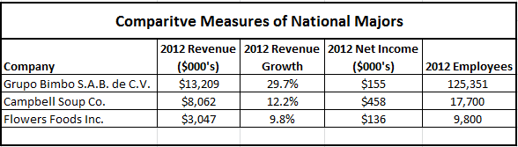

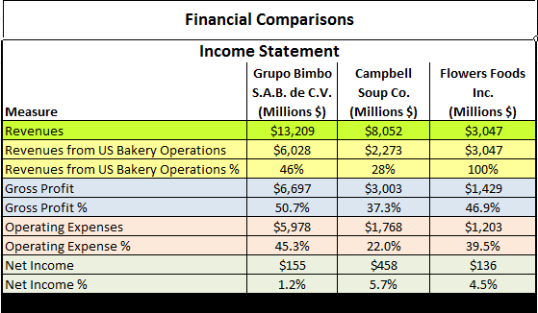

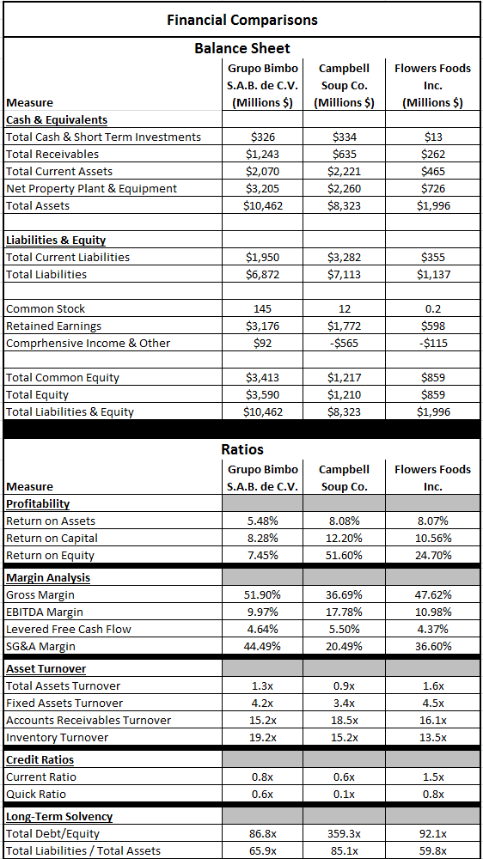

Grupo Bimbo S.A.B. de C.V. operating as Bimbo Bakeries U.S.A. in the United States

Grupo Bimbo was established in Mexico in 1945 by the Servitje family. It is a third- generation family-operated baking company. Today it is an international baking company operating in 19 countries and employs over 125,000 employees. One of its largest markets is now the U.S. In the United States, Grupo operates as Bimbo Bakeries USA (“BBU”) and its headquarters are located in Horsham, PA. BBU is currently the only company with national distribution and it operates 69 plants throughout the U.S.
In 1998, Grupo entered the U.S. market with the acquisition of Mrs. Baird’s bakeries in Texas. At the time, Mrs. Baird’s was the largest family-owned bakery in the U.S. In 2002, Grupo acquired the Western U.S. baking business of George Weston Ltd. (“GWL”) and in 2009 it purchased the remaining U.S. fresh baked goods business of GWL. GWL is a Canadian Company which had bakery operations in the U.S. Grupo acquired GWL’s U.S. operations after GWL announced a retrenchment strategy. Then, in 2011, Grupo made its latest acquisition by purchasing Sara Lee’s North American Fresh Bakery Business. Due to these acquisitions, BBU is now the largest baking company in the U.S.
Its U.S. product brand names include: Bimbo, Ball Park, Boboli, Earthgrains, Francisco, Freihoffers, Marinela, Thomas’, Oroweat, Sara Lee, Tia Rosa, Stroehmann, Entenmann’s, and Brownberry. Grupo is now the world’s largest baking company and BBU is now the largest baking company in the U.S with 18.2% market share.

The following two tables show the ratios for Grupo Bimbo as a whole and the SWOT analysis of BBU specifically.
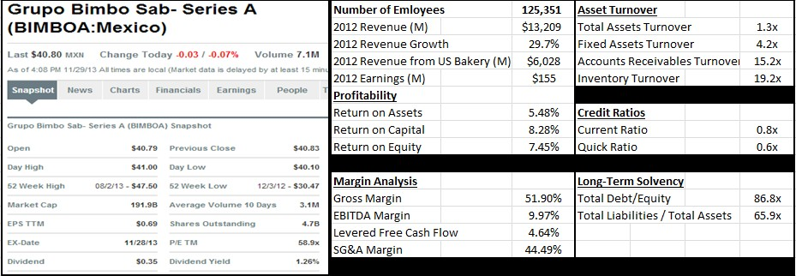

Strengths  - Largest baking company in the world  - Strong management in baking industry  - Strong regional/national brands  - Distribution Network  - Innovation  - Focus on quality  - Growing organically and through strategic acquisitions  - Leadership in a non-cyclical industry | Opportunities  - Continue Sara Lee Integration to reduce costs  - Manufacturing capabilities - accelerate construction of state-of-art facilities  - Establish presence in organic bread product segment  - Growth in sweet baked goods and breakfast category in U.S.  - Leverage IT to reduce costs asso- ciated with returns  - Continued Sustainability development  - Continue with strategic acquisitions
Weaknesses  - Low operating profit margin  - Old manufacturing facilities  - High cost distribution network  - Short shelf-life products | Threats  - Competition - Flowers Foods  - Growth of private label brands  - Raw material prices driven by climate and world demand  - Changing consumer preferences  - Consumer perception of value - economy driven

Flowers Foods, Inc.

Flowers Baking Company was founded by brothers, William and Joseph Flowers, in Thomasville, GA in 1919. Flowers is a domestic company and it is the second largest bakery in the U.S. Flowers operates 45 highly efficient bakeries that product breads, buns, rolls, snack cakes, and pastries which are distributed to foodservice and retail customers in the Southeastern, Southwestern, and mid-Atlantic states and frozen to national foodservice and retail customers.
Flowers has the potential to be a national bakery distributor within the next five years.

In 1996, Flowers acquired Keebler Foods through a joint venture and later gained majority ownership in 1998. Also, in 1996, Flowers acquired Mrs. Smith’s frozen desert brand. In 2001, Flowers sold Keebler Foods to Kellogg’s and Flowers Bakeries and Mrs. Smith Bakeries were spun off into a new company called Flowers Foods. In 2002, Flowers Foods then restructured its company into three business units – Flowers Bakeries, Flowers Snack, and Mrs. Smith’s Bakeries. However, in 2003 Mrs. Smith’s was sold to Schwan Food Company and the company then restructured into two business units – Bakeries Group and Specialty Group. In 2006, Flowers Food acquired Derst Baking Company in Savannah, GA. Flowers Food again realigned its operating structure under Flowers Bakeries. In 2009, Flowers acquired Leo’s Foods in Ft. Worth, Texas and began its presence in the tortilla market. In 2011, Flowers acquired Tastykake which had bakeries in Philadelphia and Oxford, PA.
Flowers brand names include: Nature’s Own, Whitewheat, Wonder Bread, Cobblestone Mill, Tastykake, Mrs. Freshley’s, European Bakers, BlueBird, and Mi Casa and regional brands of Merita, Home Pride, Butternut, Country Kitchens, Barowsky’s Organics, ButterKrust, Captain John Derst’s, Evangeline Maid, Sunbean, Bunny, Mary Jane, Aunt Hattie’s, Holsum, and Mary Jane & Friends and has 8.7% market share.

The following two tables show the ratios and the SWOT analysis of Flowers.
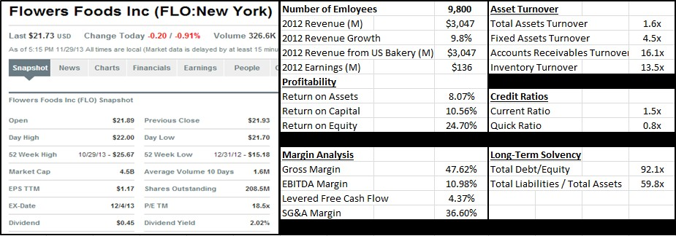

Strengths  1.Broad bakery product and brand portfolio 2.Efficiency in customer service  3.Efficient use of resources 4.Strong distribution network | Opportunities  1.Expansion through strategic acquisitions 2.Growing demand for private labels 3.Positive outlook for snacks and savory market  4.Recovering restaurant business
Weaknesses  1.Reliance on few customers 2.Significant pension obligations | Threats  - Highly competitive environment  - Fluctuations in raw material prices 3.Government regulations

Campbell’s Food Company

In 1869, Joseph Campbell and Abraham Anderson formed a company in Camden, NJ hat would one day grow into Campbell’s Food Company (“Campbell’). Campbell is, of course, known for its famous condensed soups. An interesting tidbit of information is that Campbell Soup’s label colors came about when a Campbell executive attended the Cornell-Penn football game and was so taken with Cornell’s red-and-white uniforms that he convinced Campbell to use the colors on the soup labels.
Through is many years of operations, Campbell’s has acquired several companies in many different areas of food. Although the focus of this paper is the U.S. baking industry, it is helpful to Campbell’s entire background. In 1915, Campbell acquired Franco-American Food Company. In 1922 Campbell experienced so much success with its soups that it changed its name to Campbell Soup Company. In 1948 Campbell acquired the V8 juice brand. In 1968 Campbell acquired Pepperidge Farm. In 1966, Campbell acquired the North American distribution rights to Godiva chocolates and in 1974 acquired the European Godiva candy company. In 2008, it sold Godiva to Yildiz Holding. In 1978 Vlasic Foods, Inc., which produced pickles and relishes, was acquired but was spun off in 1998. In 1992, Campbell’s purchases Arnott’s Limited, a maker of popular biscuits, of Australia. In 1995, Campbell acquired Pace Foods, a leading producer of Mexican sauces and acquired a controlling interest in a joint venture with privately-owned Cheong Chan of Petaling Jaya, Malaysia which gave
Campbell’s its first production site in Southeast Asia. In 1996, Campbell acquires the German Erasco Group and in 1997 acquired the French Liebig Company, both of which were soup companies. In 1998, Campbell acquired Fortun Foods which was a leader in refrigerated soups. In 2009, Pepperidge Farms acquired Ecce Panis, a leading producer of Artisan breads. In 2012,

Campbell’s acquired Bolthouse Farms which produced carrots and healthy drinks. In 2013, Campbell’s acquired Plum Organics, an organic foods company specializing in child nutrition and acquired Kelsen Group which produced baked snacks.
The Pepperidge Farm division of Campbell is the third major corporation in the U.S. baking industry. It was founded in 1937 by Margaret Rudkin, a wife and mother, who names the company after her family’s property in Fairfield, CT. In 1961, the company was acquired by Campbell. Pepperidge Farm has many different bread products all under the Pepperidge Farm brand name.

The following two tables show the ratios and the SWOT analysis of Campbell.

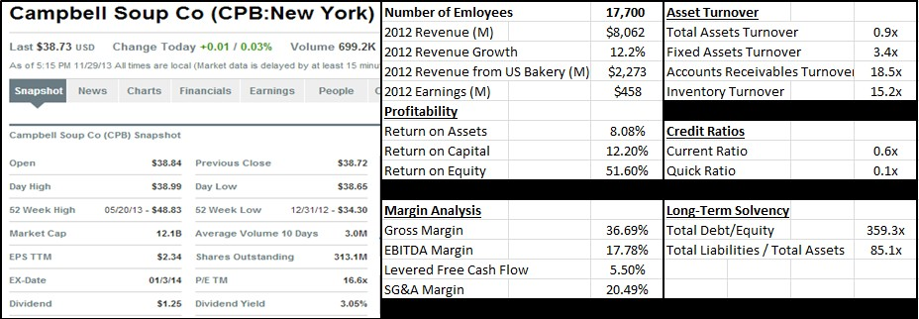

Strengths  - Steady sales figures  - Substantial market share in retail of soups 3.Innovation  4.Low production costs | Opportunities  1.Expansion of international presence 2.Continue to grow healthy beverages, baked snacks, and bread businesses  3.Continue strategic acquisitions
Weaknesses  1.Gross margins impacted by recession 2.Rise in material costs | Threats  1.Competition in bread industry 2.Government regulation  3.Low adoption rates of new products that might lead to heavy promotional and marketing expenditures

Competitor Analysis

The following positioning map shows the three major U.S. baking industry companies as well as the positioning of the various small, regional baking companies. The positions were
determined by the companies’ geographic reach and product assortment. The positions were determined by the companies’ geographic reach and product assortment.
BBU has the largest market share of the three largest competitors. The private label segment, indicated by PL, while not an actual competitive company, has even greater reach and is a competitive force that all bakeries, no matter what size, have to contend with. Most national grocery store chains have their own private label products in many food areas. The bread category is no different. Grocery store chains either have their own bakeries or those grocery stores purchase their private label form outside bakeries like BBU and Flowers. Three grocers, Kroger’s, Safeway, and HEB out of Texas, have their own baking facilities. BBU and Flowers have to manage the price gap between their branded products and the private label products that they supply to the stores to avoid customer switching. The other category, indicated by OTR, is comprised of the many, very small bakeries located throughout the U.S. While not a threat individually, that segment does have a large market share in the U.S. market.

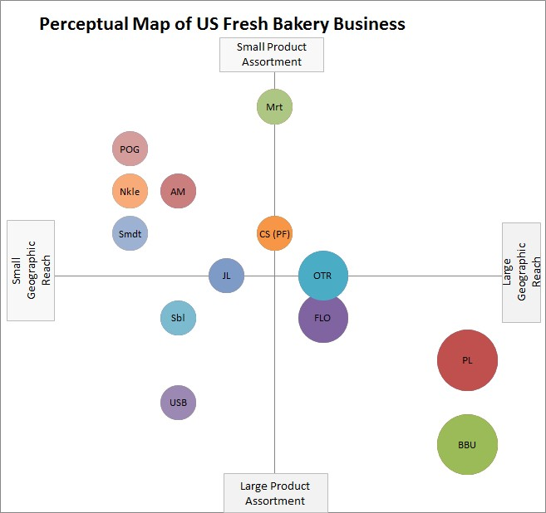

LEGEND: PL Private Label
BBU Bimbo Bakeries USA
FLO Flowers Foods, Inc.
OTR Other bakeries – very small bakeries USB United States Bakery
MRT Martins
CS (PF) Campbell Soup/Pepperidge Farm Sbl Schwebel
JL Jack Lewis Baking Company
Smdt Schmidt
Nkle Nickles
AM Aunt Millies
POG Pan O Gold

Total US - Multi Outlet Retail Market Share Retail Dollars (IRI) 52 Weeks ending 11/3/2013
Company | Sales | Share | Geographic Reach
PL- | $1,880,039,808 | 34% | 50
BBU | $1,553,618,744 | 28% | 50
FLO | $724,534,600 | 13% | 21
OTHER | $574,820,484 | 10% | 20
Pepperidge | $230,700,592 | 4% | 18
Lewis | $122,202,184 | 2% | 5
Aunt Millies | $121,232,368 | 2% | 5
Martins | $75,956,072 | 1% | 10
US Bakery | $63,920,568 | 1% | 4
Schwebel | $50,446,380 | 1% | 4
Nickles | $40,120,392 | 1% | 3
Schmidt | $36,876,844 | 1% | 3
Pan O Gold | $28,577,456 | 1% | 3
TOTAL | $5,503,046,492

Industry Prospects and Overall attractiveness

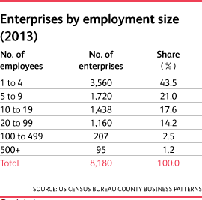
Currently the top companies in the baking industry such as BBU and Flowers that have 500+ employees only consist of 1.2% of bakeries in the industry. This shows that about 65% of all bakeries employ less than ten people. Many of these are local and serve a small portion of the entire population, they are scattered throughout the country and often cater to a specialty market such as those with nut allergies or who
prefer organic/all natural items. This diversity is why concentration in the industry is extremely low, but with these larger firms continuing to acquire the smaller bakeries in the future the concentration of the baking industry is going to increase.
Competition in the baking industry is high, and steadily increasing. With most bakeries being small to medium sized this shows how diverse and scattered the marketplace is. The major brands in the industry are competing against these local/regional bakeries that have specialized products, and generally are made with higher quality ingredients. For the baking industry competition is based on four main factors: price, quality, product differentiation, and nutritional value. While generally price and quality are related for consumer goods baking products are no different. While price is always a factor the value of an item can make price unimportant. These specialty bakeries can create the value consumers want for those specialized items, and charge a little more for them without losing customers. Customers see the specialized items as valuable, and with that price is not as strong of a factor any longer. Clearly as mentioned before product differentiation is a huge factor in the baking industry, customers are looking for more specialized

products that the smaller bakeries can provide. The larger bakeries such as BBU and Flowers see the increasing need for these specialized products and in turn have begun to acquire the larger more regional bakeries to add differentiation to their product portfolios.
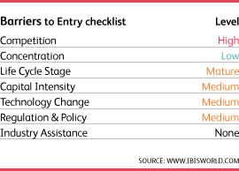
Entering the baking industry on a commercial level is difficult due to the recognition and prices of the brands as well as manufacturing and distribution costs to produce and distribute on such a wide scale. Entering the baking industry on a smaller scale is easier, all that is needed is the
startup cost for a facility and equipment to begin production. Two main threats face new entrants, industry’s major brands and obtaining contracts. The industry’s major brands have the recognition and consumer loyalty that can be extremely difficult to overcome. The more successful small bakeries appeal to those specialized market segment and begin to develop loyalty with that smaller customer base. The other threat that a new entrant can face is the challenge of obtaining contracts with supermarkets. Since supermarkets choose items that sell well this makes it almost impossible for unknown brands to obtain shelf space in large supermarket chains. The way around this is to open a stand-alone bakery (which can add to the startup cost) or pairing with local grocery stores or markets to help build up that brand awareness.

Conclusion

Baking has been an important part of human life for centuries and it is almost certain it will continue to be that way. The population in general here in the United States loves their baked goods and that is a big win for the baking industry. As we have seen there are very few barriers that would stop entry into the industry. Some of the big barriers that keep companies from gaining or maintaining success is the lack of capital, brand recognition and high cost of materials and labor. Those companies that are able to function and survive despite these barriers can enjoy a lot of success as there is relatively few competitors. As stated there are six key factors that can help to determine whether a baking company will be successful of not. They are
1) the ability to pass on cost increases, 2) Supply contracts in place for key inputs, 3) Proximity to key markets, 4) Use of the most efficient work practices, 5) Product differentiation, and 6) Establishment of brand names. If new entrants in the baking industry or if existing companies within the industry are able to utilize these factors as well as avoid some of the costly barriers in the industry, they will be able to bring joy to many homes for many years to come and the industry itself will enjoy many years of growth and success.

References

http://www.grupobimbo.com/informe/Bimbo-Informe-Anual-2012/en/financial/ http://clients1.ibisworld.com.proxy.lib.csus.edu/reports/us/industry/default.aspx?entid=261 http://www.mbaskool.com/brandguide/food-and-beverages/5421-campbell-soup.html http://www.flowersfoods.com/FFC_CompanyInfo/HistoricalHighlights/index.cfm http://clients1.ibisworld.com.proxy.lib.csus.edu/reports/us/industry/competitivelandscape.aspx?e ntid=261
http://www.bloomber/g.com/quote/BIMBO http://investor.campbellsoupcompany.com/phoenix.zhtml?c=88650&p=irol-reportsannual A:MM
http://clients1.ibisworld.com.proxy.lib.csus.edu/reportsus/industry/default.aspx?entid=261 http://www.mbaskool.com/brandguide/food-and-beverages/5421-campbell-soup.html http://www.flowersfoods.com/FFC_CompanyInfo/HistoricalHighlights/index.cfm http://www.merriam-webster.com/dictionary/baking http://www.britannica.com/EBchecked/topic/49594/baking http://www.pfisterconsulting.com/history.htm
http://americanbakers.org/ http://www.scribd.com/doc/3699043/BreadTalk-FinalReport

