Birthday party invitation

1. What’s the word?

Write the word under the pictures.

birthday | party | date | street | time | telephone

birthday

2. Read and circle!
Read the birthday party invitation and circle the examples of the top tips.
Top tips for writing birthday party invitations!
- Start the invitation To + name.

- Start days and months with a capital letter.

- End the
invitation with From + name.

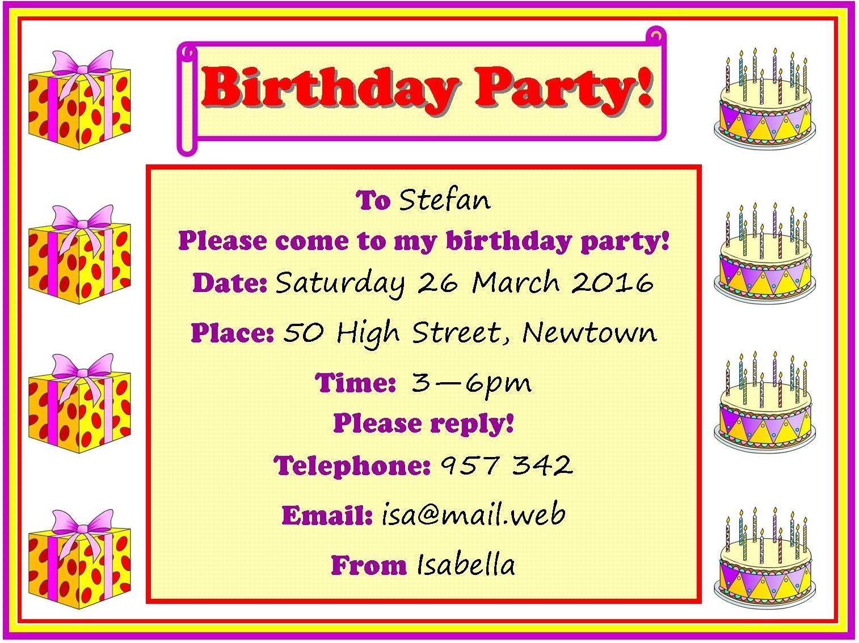www.britishcouncil.org/learnenglishkids
© The British Council, 2016 The United Kingdom’s international organisation for educational opportunities and cultural relations. We are registered in England as a charity.

3. Fill it in!
Write the missing words in the sentences.
a. | To Stefan
b. | Please come to my party!
c. | : Saturday 26 March 2016
d. | : 50 High Street, Newtown
e. | Time: 3–6
f. | Please !
g. | : 957 342
h. | Isabella

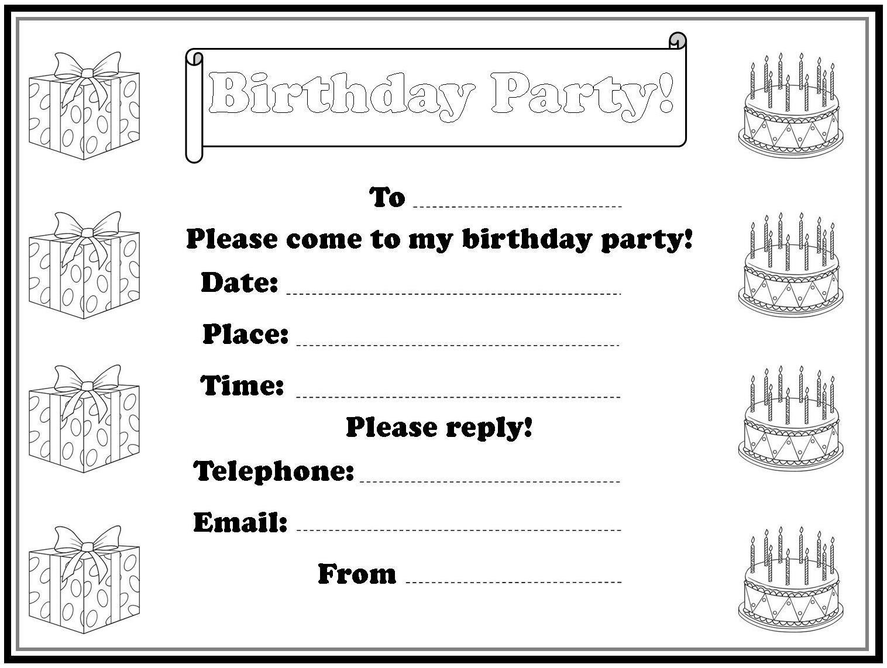
4. Practise writing!
Write an invitation to your party! Think about these questions first: Who is the invitation for? What date is the party? Where is the party? What time is the party?

www.britishcouncil.org/learnenglishkids
© The British Council, 2016 The United Kingdom’s international organisation for educational opportunities and cultural relations. We are registered in England as a charity.

