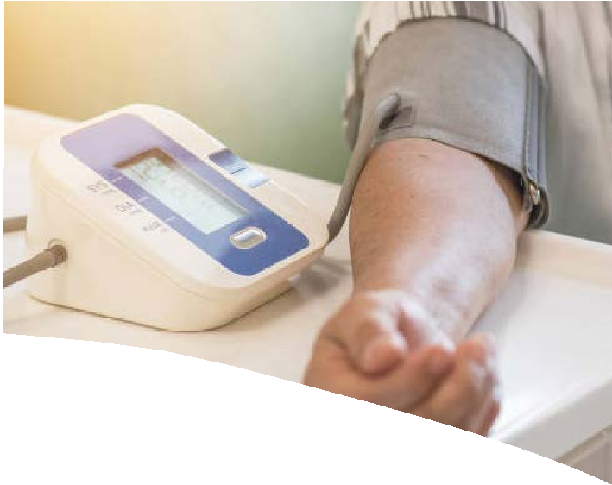
My Blood Pressure Log
Try these tips for keeping track of your blood pressure at home:
- Always take your blood pressure at the same time every day.
- Take at least two readings, 1 or 2 minutes apart.
- Visit cdc.gov/bloodpressure to learn how to correctly measure your blood pressure.

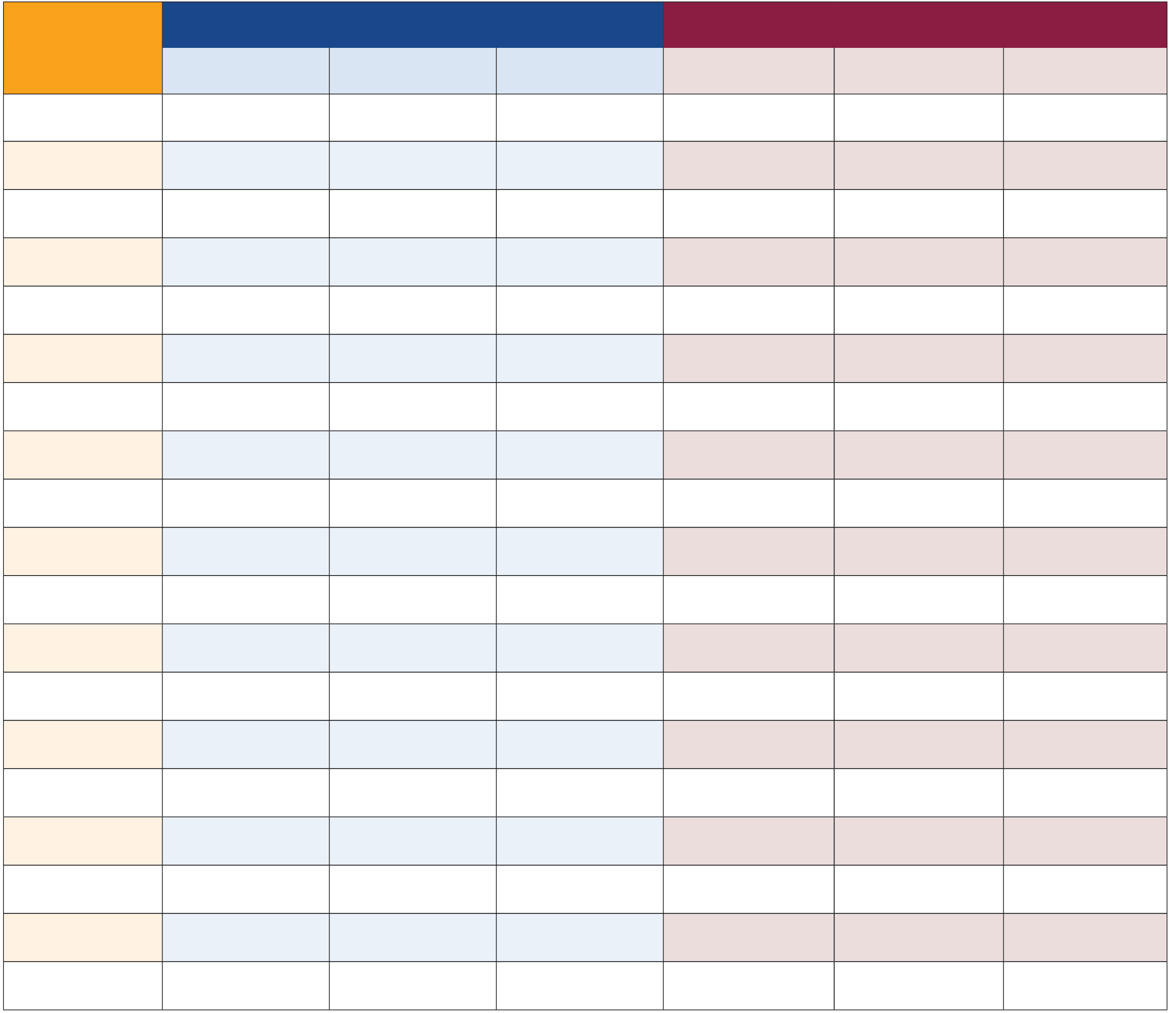
Morning Evening
Date | Time of reading | Reading 1 | Reading 2 | Time of reading | Reading 1 | Reading 2
Sept. 1, 2022 | 8 a.m. | 139/82 | 141/82 | 6 p.m. | 145/85 | 142/83



